**Architecture Description**

**GPT-Assisted Coding Trainer**

**Software System for Training Coding with GPT Assistance**

**May 2023**

**Revision History**

|  |  |  |  |
| --- | --- | --- | --- |
| **Version** | **Date** | **Author** | **Revisions Made** |
| **0.8** | **6/07(Wed), 9pm** | **박종안** | **(Interim) Refining SRS & Context View** |
| **0.9** | **6/20(Tue), 9pm** | **박종안** | **(Pre-final) Schematic Architecture and Viewpoints** |
| 1.0 | 7/03(Mon), 9pm | 박종안 | (Final) Design for NFRs and Validation |

**삼성전자 첨단기술아카데미**

**Table of Contents**

1. Introduction 7

1.1. Purpose of the Document 7

1.2. System of Interest 7

1.3. Definitions, Acronyms, and Abbreviations 7

1.4. References 9

1.5. Process applied to Architecture Design 9

1.6. Template used for Architecture Description 11

2. Activity 1. Architectural Requirement Refinement 11

2.1. [Step 1] Identify Stakeholders 11

2.2. [Step 2] Refining Functional Requirements 12

2.3. [Step 3] Architectural Concerns 12

2.4. [Step 4] Refine Non-Functional Requirements 14

2.5. [Step 5] Write Refined Software Requirement Specification 15

3. Activity 2. System Context Analysis 15

3.1. [Step 1] System Boundary Context 15

3.1.1. Level 0 DFD for the Boundary Context 15

3.1.2. Description of the Context Diagram 16

3.2. [Step 2] Functional Context 17

3.2.1. Representing the Functional Context 17

3.2.2. Defining Functional Groups 18

3.2.3. Defining Actors 18

3.2.4. Defining Use Cases 19

3.2.5. Context-level Use Case Diagram 19

3.3. [Step 3] Information Context 19

3.3.1. Representing the Information Context 19

3.3.2. Identifying Persistent Object Classes 20

3.3.3. Context-level Class Diagram 20

3.4. [Step 4] Behavioral Context 21

3.4.1. Representing the Behavior Context 21

3.4.2. Allocate Functionality over Tiers 21

3.4.3. Define Invocation Patterns 21

3.4.4. Context-level Activity Diagram 23

3.5. [Step 5] Additional Contexts 24

4. Activity 3. Schematic Architecture Design 25

4.1. [Step 1] Observe Architectural Characteristics 25

4.2. [Step 2] Candidate Architecture Styles 25

4.3. [Step 3a] Evaluating ‘Candidate 1. MVC Architecture Style’ 25

4.3.1. Evaluate the Applicable Situations 25

4.3.2. Evaluate the Benefits 26

4.3.3. Evaluate the Drawbacks 26

4.3.4. Result of the Evaluation 26

4.4. [Step 2b] Evaluating ‘Candidate 2. Event-driven Architecture Style’ 26

4.4.1. Evaluate the Applicable Situations 26

4.4.2. Evaluate the Benefits 27

4.4.3. Evaluate the Drawbacks 27

4.4.4. Result of the Evaluation 27

4.5. [Step 2c] Evaluating ‘Candidate 3. Dispatcher Architecture Style’ 27

4.5.1. Evaluate the Applicable Situations 28

4.5.2. Evaluate the Benefits 28

4.5.3. Evaluate the Drawbacks 28

4.5.4. Result of the Evaluation 28

4.6. [Step 2e] List of Selected Architecture Styles 28

4.7. [Step 3] Applying Architecture Styles 29

4.7.1. Applying MVC Architecture Style 29

4.7.2. Applying Event-driven Architecture Style 29

4.7.3. Applying Dispatcher Architecture Style 30

4.7.4. Resulting Schematic Architecture 31

4.8. [Step 4] Refining Interaction Paths 31

4.8.1. Interaction Paths derived from the Styles 32

4.8.2. Refinements on the Default Interaction Paths 32

4.9. [Step 4] Elaborating the Schematic Architecture 32

4.9.1. Strengths 32

4.9.2. Drawbacks 32

5. Activity 4. View-specific Architecture Design 33

5.1. Functional View 33

5.1.1. [Step 1] Observe Functional Characteristics 33

5.1.2. [Step 2] Refine Use Case Diagram 33

5.1.3. [Step 3] Derive Functional Components 35

5.1.4. [Step 4] Refine Functional Components for Tiers 36

5.1.5. [Step 5] Allocate Functional Components 37

5.1.6. [Step 6] Design Functional Components 39

5.1.7. [Step 7] Define Interfaces of Functional Components 40

5.2. Information View 41

5.2.1. [Step 1] Observe Informational Characteristics 41

5.2.2. [Step 2] Refine Persistent Object Model 41

5.2.3. [Step 3] Derive Data Components 43

5.2.4. [Step 4] Refine Data Components for Tiers 44

5.2.5. [Step 5] Allocate Data Components 44

5.2.6. [Step 6] Design Data Components 46

5.2.7. [Step 7] Define Interfaces of Data Components 46

5.3. Behavioral View 46

5.3.1. [Step 1] Observe Behavioral Characteristics 46

5.3.2. [Step 2] Refining Control Flow of the Platform 47

5.3.3. [Step 3] Choosing Element for Detailed Control Flow 50

5.3.4. [Step 4] Detailed Control Flow for ‘Create GPT Prompt to evaluate.’ 50

5.4. Deployment View 53

5.4.1. [Step 1] Observe Deployment Characteristics 53

5.4.2. [Step 2] Define Nodes 53

5.4.3. [Step 3] Define Network Connectivity 54

5.4.4. [Step 4] Define Artifacts to Deploy 54

5.4.5. [Step 5] Allocate Artifacts on Nodes 54

6. Activity 5. NFR-specific Architecture Design 56

6.1. Design for High Reliability of the System 56

6.1.1. [Step 1] Identify Facts and Policies 56

6.1.2. [Step 2] Define Criteria for Tactics 57

6.1.3. [Step 3] Define Candidate Tactics 57

6.1.4. [Step 4] Evaluate Candidate Tactics 64

6.1.5. [Step 5] Analyze Impacts of Tactics 64

6.1.6. [Step 6] Apply Tactics 65

6.1.7. [Step 7] Validate Conformance 67

6.2. Design for NFR-2. High Personalization of Instruction and Coding Exercises 67

6.2.1. [Step 1] Identify Facts and Policies 68

7. Activity 6. Architecture Validation 68

7.1. [Step 1] Presenting ATAM 68

7.2. [Step 2] Presenting Business Drivers 68

7.3. [Step 3] Presenting the Architecture 69

7.4. [Step 4] Identifying the Architectural Approaches 69

7.5. [Step 5] Generating Quality Attribute Tree 69

7.6. [Step 6] Analyzing Architectural Approaches 71

7.7. [Step 7] Brainstorming and Prioritizing Scenarios 72

7.8. [Step 8] Analyzing Architectural Approaches 73

7.9. [Step 9] Presenting the Results 73

8. Concluding Remarks 74

**List of Figures**

Figure 1. Concept of the GPT-Assisted Coding Trainer System 7

Figure 2. Process to design Software Architecture 10

Figure 3. Degree of Relevance of NFRs to Stakeholders 14

Figure 4. DFD Diagram for Boundary Context 16

Figure 5. Use Case Diagram for the Functional Context 19

Figure 6. Class Diagram for showing Information Context 20

Figure 7. Activity Diagram for showing Behavior Context of System 23

Figure 8. Activity Diagram for showing Behavior Context of SW Agent 24

Figure 9. Applying MVC Architecture Style 29

Figure 10. Applying Event-driven Architecture Style 30

Figure 11. Applying Dispatcher Architecture Style 30

Figure 12. Resulting Schematic Architecture 31

Figure 13. Refined Use Case Diagram 34

Figure 14. Deriving Functional Components 35

Figure 15. Functionality Place Holders of the Target System 37

Figure 16. Allocaiton of Components on Functionality Place Holders 39

Figure 17. Refined Class Diagram 42

Figure 18. List of Data Components 43

Figure 19. Data Component Holders of the Target System 45

Figure 20. Allocation of Data Components 45

Figure 21. Refined Control Flow of Explicit Functional Group 48

Figure 22. Refined Control Flow of SW Agent(Event-based, Timer) 49

Figure 23. Target Element for Designing Detailed Control Flow 50

Figure 24. Detailed Control Flow of Create Evaluation GPT Prompt 51

Figure 25. Deployment Diagram for the Target System 55

**List of Tables**

Table 1. Profiles of Stakeholders 12

Table 2. Relevance of NFRs to Stakeholders 13

Table 3. Allocation of Functionality over Tiers 21

Table 4. Invocation Patterns defined for Functional Groups 22

Table 5. Functional Components and their Use Cases 36

Table 6. Functional Components of Dispatcher Architecture Style 36

Table 7. Partitioning Functional Components 38

Table 8. Design of Functional Components 40

Table 9. Data Components allocated on Tiers 44

Table 10. Invocation Patterns defined for Functional Groups 46

**Architecture Description of  
GPT-Assisted Coding Trainer**

# Introduction

## Purpose of the Document

The purpose of this document is to specify the architecture design for the target system. It describes all the essential architectural aspects of the target system including its structure, functional components, data components, their relationships, runtime behavior, and deployment.

## System of Interest

The system of interest is Coding Trainer which is a software system, designed to facilitate the teaching of programming languages without the need for human instructors. GPT-Assisted Coding Trainer is an advanced coding trainer that harnesses the power of GPT-4 to deliver its core functionality. The system leverages the capabilities of the GPT-4 model through its API to perform essential tasks and provide a comprehensive learning experience.

The GPT-Assisted Coding Trainer takes advantage of the latest advancements in GPT language modeling and artificial intelligence to create an immersive and effective learning environment for programming languages.

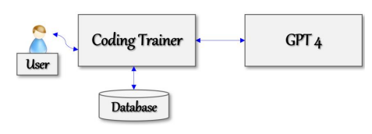

Figure 1. Concept of the GPT-Assisted Coding Trainer System

The system is deployed as a web server, which subscribes to GPT 4, as shown in the Figure 1. A user interacts only with the Coding Trainer, not directly with GPT 4. The system maintains a database for managing the essential datasets such as user profiles, programming language profile, sessions for using the system including teaching contents, exercise problems, users’ program codes, and their evaluations.

## Definitions, Acronyms, and Abbreviations

* GPT (Generative Pre-trained Transformer)

GPT refers to a type of artificial intelligence model developed by OpenAI. GPT models are based on the Transformer architecture, which is a deep learning model architecture known for its ability to handle sequential data efficiently.

GPT models are renowned for their ability to generate coherent and contextually relevant text. They can be used for various natural language processing tasks, including language translation, text summarization, chatbot interactions, and creative writing assistance.

* Language Profile

Language Profile serves as a meta-description of each programming language and is defined by the course director.

Language Profile includes the following attributes:

* Profile Name
* List of Units in the programming language
* List of Topics for each Unit

The content of a unit is further organized into topics, with each topic representing a specific language construct related to the unit's main theme.

* Unit

The content of a programming language is organized into units, with each unit representing a key topic or concept of the language.

* Topic

The content of a unit is further organized into topics, with each topic representing a specific language construct related to the unit's main theme.

* Quantitative Evaluation

GPT-Assisted Coding Trainer offers a quantitative evaluation of user submissions, utilizing a rating scale ranging from 1 to 10. This evaluation provides a measurable assessment of the quality or performance of the submitted code.

* Qualitative Evaluation

The system goes beyond quantitative evaluation and provides comprehensive feedback on user submissions. It offers a detailed analysis that highlights the strengths and weaknesses of the code. The feedback includes explanations for necessary corrections, suggestions for improvement, and alternative approaches to writing the code. This thorough feedback helps users understand their mistakes, learn from them, and enhance their coding skills effectively.

* Training Report

Training Report represents comprehensive reports on the learning progress of learners and certificates of completion.

* Progress Report

This progress report provides comprehensive details of the training sessions conducted. It encompasses the complete history of training sessions conducted for the specific programming language, highlighting the exercises undertaken and the evaluation results of code submissions.

* Certificate of Completion

This certificate confirms that the recipient has successfully completed all the required training units and fulfilled the necessary criteria for certification. It is a concise, one-page document that bears the official seal of the training institute.

## References

[Kim 23a] Soo Dong Kim, Associate Architect Program, 2023-A3, CEP Specification of GPT-Assisted Coding Trainer*,* Version 0.9, 삼성전자 첨단기술 아카데미, May 2023.

[Kim 23b] Soo Dong Kim, Associate Architect Program, 2023-A3, CEP Template for GPT-Assisted Coding Trainer, 삼성전자 첨단기술 아카데미, May 2023.

[Kim 23c] Soo Dong Kim, Architecture Design Process & Instructions, 2023-A3, Lecture Note #1, 삼성전자 첨단기술 아카데미, May 2023.

[Kim 23d] Soo Dong Kim, Associate Architect Program, 2023-A3, CEP Specification of GPT-Assisted Coding Trainer*,* Version 1.0, 삼성전자 첨단기술 아카데미, May 2023.

[ISO 42010] ISO/IEC/IEEE, *Systems and software engineering - Architecture description*, pp. 46, Dec. 2011.

## Process applied to Architecture Design

The process applied to designing software architecture in this sample solution is given [KIM 22c]. It consists of the following six activities as shown in Figure 2.

Figure 2. Process to design Software Architecture

* Activity 1. Architectural Requirement Refinement

This activity is to refine the given requirements for developing a target system.

Software Requirement Specification should be refined before designing the architecture of the target system. The principles of requirement engineering can be well applied in this activity.

* Activity 2. System Context Analysis

This activity is to analyze the given requirements for comprehending the target system before making any architectural decisions. The initial comprehension of the target system is specified in the context model of the target system.

* Activity 3. Schematic Architecture Design

This activity is to design the initial and high-level architecture of the target system, called schematic architecture. This architecture mainly specifies the structural aspect of the target system and becomes the stable basis for making additional architectural decisions and defining more detailed architectural elements accordingly.

The schematic architecture can effectively be derived by utilizing architectural styles.

* Activity 4. View-specific Architecture Design

This activity is to specify more detailed architectural elements for different views. It is advantageous to separate architecture design activities by view, backed by the principle of separate of concerns. Essential Views of Software Architecture are Functional view, Information view, Behavior view, and Deployment view. Utilize viewpoints.

* Activity 5. NFR-specific Architecture Design

This activity is to refine the architecture with additional architectural decisions for each NFR item. Each NFR is thoroughly analyzed, and effective architectural tactics are defined to fulfill the NFR. Then, the existing architecture is refined with defined architectural tactics.

* Activity 6. Architecture Validation

This activity is to validate the resulting architecture design of the target system for both functional and non-functional aspects.

Architecture description becomes a concrete baseline document on which detailed system design is made for implementation. Hence, this activity is essential to confirm the fulfillment of both the functional and non-functional requirements.

## Template used for Architecture Description

The template used for writing this architect description is given in [Kim 23b].

# Activity 1. Architectural Requirement Refinement

This chapter describes the refinements made over the initial requirements of the target system.

## [Step 1] Identify Stakeholders

A stakeholder can be an individual, a group, or an organization. Stakeholders have interests on the target system and concerns that are used as key drivers for designing architecture.

* Stakeholder 1. System Manager

This represents the staff who will manage the overall operation of the Coding Trainer system.

* Stakeholder 2. Client

This represents the organization that will sponsor the development of the system and distribute the system to application users.

* Stakeholder 3. Learner

This represents a learner who uses the Coding Trainer to learn a program language through this system.

* Stakeholder 4. Course Director

This represents the course director who responsible for managing program Language course contents(Language Profile).

The profile of each stakeholder is summarized in Table 1.

Table 1. Profiles of Stakeholders

|  |  |  |  |
| --- | --- | --- | --- |
| **Stakeholder Group** | **Representative Name** | **Contact Information** | **Availability** |
| System Manager | Linda Johnson | 251-546-9442 Gulf Shores, AL | After 2pm, only on F, Phone Only |
| Client | James Brown | 415-546-4478 San Francisco, CA | Before Noon, MWF, Phone Only |
| Learner | Susan Tayler | 949-569-4371 Santa Clara, CA | 10-Noon, T. Th, Office Visits |
| Course Director | David Harris | 408-925-1352 San Jose, CA | All Day, M-F,  Phone Only |

[Step 2] Refining Functional Requirements

Utilize the *SRS Refinement Table* to document the results of requirement refinement.

* Deficiency #1

|  |  |  |  |  |  |
| --- | --- | --- | --- | --- | --- |
| **Deficiency ID** | FR.DEF.01 | **Deficiency Type** | Ambiguity | **Location** | SRS 4.4 |
| **Original Context** | “Learners have the opportunity to engage with the system by typing questions or queries, and the system responds with appropriate and accurate answers.” | | | | |
| **Questioning** | Is Learner always able to ask questions in any session? | | | | |
| **Refined Context** | No. After each Topic's Foundation, exercise, and submitted code evaluation, a question box will be created to ask questions. | | | | |

* Deficiency #2

|  |  |  |  |  |  |
| --- | --- | --- | --- | --- | --- |
| **Deficiency ID** | FR.DEF.02 | **Deficiency Type** | Ambiguity | **Location** | SRS 4.6 |
| **Original Context** | “Upon completion of the exercise, learners can submit their program codes through the system's interface.” | | | | |
| **Questioning** | What are the methods of the system interface for submitting program code? | | | | |
| **Refined Context** | The system interface supports direct typing and file upload. File uploads support txt, jpg, and png files. | | | | |

## [Step 3] Architectural Concerns

An architectural concern is a feature or a characteristic of the target system that are raised and defied by stakeholder(s). Hence, architectural concerns represent the stakeholders’ view on the target system and its architecture. Consequently, architectural concerns are expressed in the application domain language, rather than technology languages.

Many of the architectural concerns are requirements and expectations about the target system. And, in fact, many of the concerns in a target system may already be represented in the SRS of the target system in the forms of functional and non-functional requirement items.

The following concerns are acquired from the stakeholders.

* Concern-1. Stable Operation of Coding Trainer

The target system provides services potentially to a large number of users, and hence the system should be designed to provide high-level reliability.

* Concern-2. Efficient Personalization for Leaners

The system should be designed to offer a high level of personalization.

* Concern-3. Accuracy of Language Profile

The system should be designed that directors provide an accurate language profile.

Merge newly derived NFR items and the NFR items of the SRS. We now have 2 NFR items.

* Concern-1. Stable Operation of Coding Trainer 🡪  
   (NFR #1) High Reliability of the System
* Concern-2. Efficient Personalization for Leaners 🡪  
   (NFR #2) High Personalization of Instruction and Coding Exercises
* Concern-3. Accuracy of Language Profile 🡪 NFR #3 ((Newly Added)

We define the relevance of NFR items to the identified stakeholder using the template in Table 2.

Table 2. Relevance of NFRs to Stakeholders

|  |  |  |  |  |  |  |  |
| --- | --- | --- | --- | --- | --- | --- | --- |
| **NFR Items** | **Relevance to Stakeholders** | | | | **Average Relevance** | **Standard Deviation** | **Selection (Y/N)** |
| Learner | System Manager | Client | Course Director |
| NFR-1 | 2 | 2 | 2 | 1 | 1.5 | 0.58 | Y |
| NFR-2 | 2 | 0 | 2 | 0 | 1 | 1.15 | Y |
| NFR-3 | 2 | -1 | -1 | 2 | 0.5 | 1.73 | N |

We apply a 5-level Relevance rating scheme as shown in Figure 3 to fill in the table.



Figure 3. Degree of Relevance of NFRs to Stakeholders

We apply the following guidelines for choosing NFR items

* Case 1) High Average Relevance & Low Standard Deviation ⇒ Choose!
* Case 2) Medium Average Relevance & Low Standard Deviation ⇒ May choose with justification!
* Case 3) Medium Average Relevance & High Standard Deviation ⇒ May not choose with justification!
* Case 4) Low Average Relevance ⇒ Do not choose!
* Case 5) High Average Relevance & High Standard Deviation ⇒ Would not occur.
* Case 6) Low Average Relevance & High Standard Deviation ⇒ Would not occur.

As the result of quantitative assessment on NFR items, we choose NFR-1 and NFR-2.

## [Step 4] Refine Non-Functional Requirements

Utilize the *SRS Refinement Table* to document the results of requirement refinement.

* Deficiency #1

|  |  |  |  |  |  |
| --- | --- | --- | --- | --- | --- |
| **Deficiency ID** | NFR.DEF.01 | **Deficiency Type** | Ambiguity | **Location** | SRS 5.1 |
| **Original Context** | “Reliability in ISO 9126 is defined with three sub-quality attributes, and they should be satisfied by the system.” | | | | |
| **Questioning** | In order to satisfy the reliability of ISO 9126, I think we need to run a redundant server. How many units can we operate? | | | | |
| **Refined Context** | It's good to run a lot of servers, but we need to minimize costs due to financial problems. | | | | |

* Deficiency #2

|  |  |  |  |  |  |
| --- | --- | --- | --- | --- | --- |
| **Deficiency ID** | NFR.DEF.02 | **Deficiency Type** | Incompleteness | **Location** | SRS 5.2 |
| **Original Context** | the system should be designed to offer a high level of personalization across three key aspects | | | | |
| **Questioning** | What is the third key aspect? | | | | |
| **Refined Context** | Personalizing the solution evaluation.  The evaluation of the solution code should be based on the individual's code and convey information that fits the individual's competency, such as advantages, disadvantages, and points to be improved. | | | | |

The resulting SRS now becomes more complete and well-aligned with stakeholders’ concerns.

## [Step 5] Write Refined Software Requirement Specification

The revised SRS is available here [KIM 23d].

# Activity 2. System Context Analysis

This chapter specifies the context of the target system in terms of the followings.

* Target System and Its Boundary
* Functionality provided by the system
* Information manipulated in the system
* Runtime behavior of the system

Additional type of the context can be described.

[Step 1] System Boundary Context

The target system may interact with users, hardware devices, external systems or other sources in the operational environment. *System Boundary Context* describes the boundary of the system and elements in the environment which interact with the target system. This helps architect and developers to clearly understand the scope of the system.

We use *Context Diagram*, i.e., Level 0 of Data Flow Diagram (DFD), which shows each tier of the target system as a process and relationships with its environment.

### Level 0 DFD for the Boundary Context

The target system is a versatile software platform designed to support the development of various applications. The architectures of Coding Trainer consist of 1 tier and accordingly the context diagram includes 1 process.

We define the boundary context in a DFD, as shown in Figure 4.

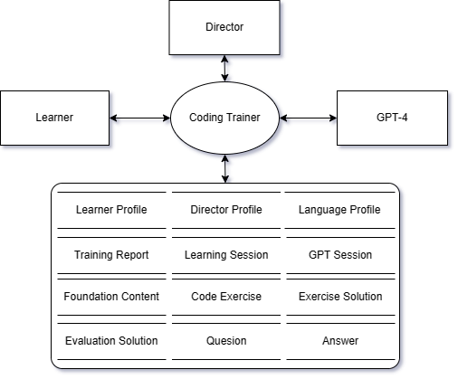

Figure 4. DFD Diagram for Boundary Context

### Description of the Context Diagram

* Process

The system consists of 1 tier and each tier is represented as a process of DFD.

* Coding Trainer
* Terminals

A terminal represents a source providing inputs to the system and/or a destination consuming output from the system.

* The terminals of human user types are *Learner, Director* and System *Manager*.
* Learner

This represents learners who are responsible for managing learner profile and training reports.

* Director

This represents course directors who are responsible for managing language profile.

* Administrator

This represents administrator who is responsible for activating director profile & language profile and deactivating director profile & language profile.

* The terminal of external system is *GPT-4.*
* GPT-4

The system leverages the capabilities of the GPT-4 model through its API to perform essential tasks and provide a comprehensive learning experience.

* Store
* The application maintains a number of distinct data stores. All the essential persistent information is captured in the data store set.
* Learner Profile

The Learner Profile includes the following attributes: name, official identification, address, phone, email, and affiliation. Learners also register their login ID and password.

* Director Profile

The Director Profile includes the following attributes: name, official identification, director identification, address, phone, email, department, specialty, and courses managed. Directors also register their login ID and password.

* Language Profile

The Language Profile includes the following attributes: Profile ID, Programming Language Name, Units, and Topics

* Training Report

The Training Report includes the following attributes: Certification

* Learning Session

The Learning Session includes the following attributes: Language Progress, Unit Progress, Topic Progress.

* GPT Session

The GPT Session include Generated GPT Prompt and GPT Completion.

* Foundation Content
* Code Exercise
* Exercise Solution
* Evaluation Solution
* Q&A List
* Data Flow

An arrow between two elements depicts a flow of data, and the names of the data on arrows are omitted in the diagram.

[Step 2] Functional Context

### Representing the Functional Context

The functional context of the target system can be well described with a use case diagram and descriptions of the use cases. A use case diagram shows the whole functionality of the target system. It is specified with Include actors, use cases, and their relationships.

### Defining Functional Groups

We apply a scheme for numbering the use cases by considering functional groups. A functional group is a collection of *closely related* use cases. And we assign a two-character prefix to each functional group. A use case diagram with use case identification numbers becomes easier to comprehend and to manage.

Based on the given SRS, we identify the following functional groups and their prefixes.

* Learner Profile Management (LE)
* Director Profile Management (DI)
* Administrator Profile Management (AD)
* Language Profile Management (LA)
* Foundation Teaching (FT)
* Exercise Generation (EG)
* Solution Evaluation (SE)
* Training Report Generation (RP)
* Question Answer (QA)
* Training Operation (TO)

### Defining Actors

We define actors that interact with the use cases. Each functional group is given its relevant actors as shown below.

|  |  |  |
| --- | --- | --- |
| **Actors**  **Functional Groups** | **Active Actors** | **Passive Actors** |
| Learner Profile Management (LE) | Learner |  |
| Director Profile Management (DI) | Director, Administrator |  |
| Administrator Profile Management (AD) | Administrator |  |
| Language Profile Management (LA) | Director, Administrator |  |
| Foundation Teaching (FT) | Foundation Agent | GPT-4 |
| Exercise Generation (EG) | Exercise Agent | GPT-4 |
| Solution Evaluation (SE) | Evaluation Agent | GPT-4 |
| Training Report Generation (RP) | Learner,  Foundation Agent,  Exercise Agent,  Evaluation Agent,  Question Agent | GPT-4 |
| Question Answer (QA) | Question Agent | GPT-4 |
| Training Operation (TO) | Learner | Foundation Agent,  Exercise Agent,  Evaluation Agent,  Question Agent |

### Defining Use Cases

The use cases in the diagram can be derived from the functional requirement of SRS. The name of each use case begins with a prefix which indicates the functional group it belongs to. The use cases in a functional group are placed together in the diagram for readability.

A use case typically has an active actor and optional passive actors.

### Context-level Use Case Diagram

The use case diagram for the functional context is shown in Figure 5.

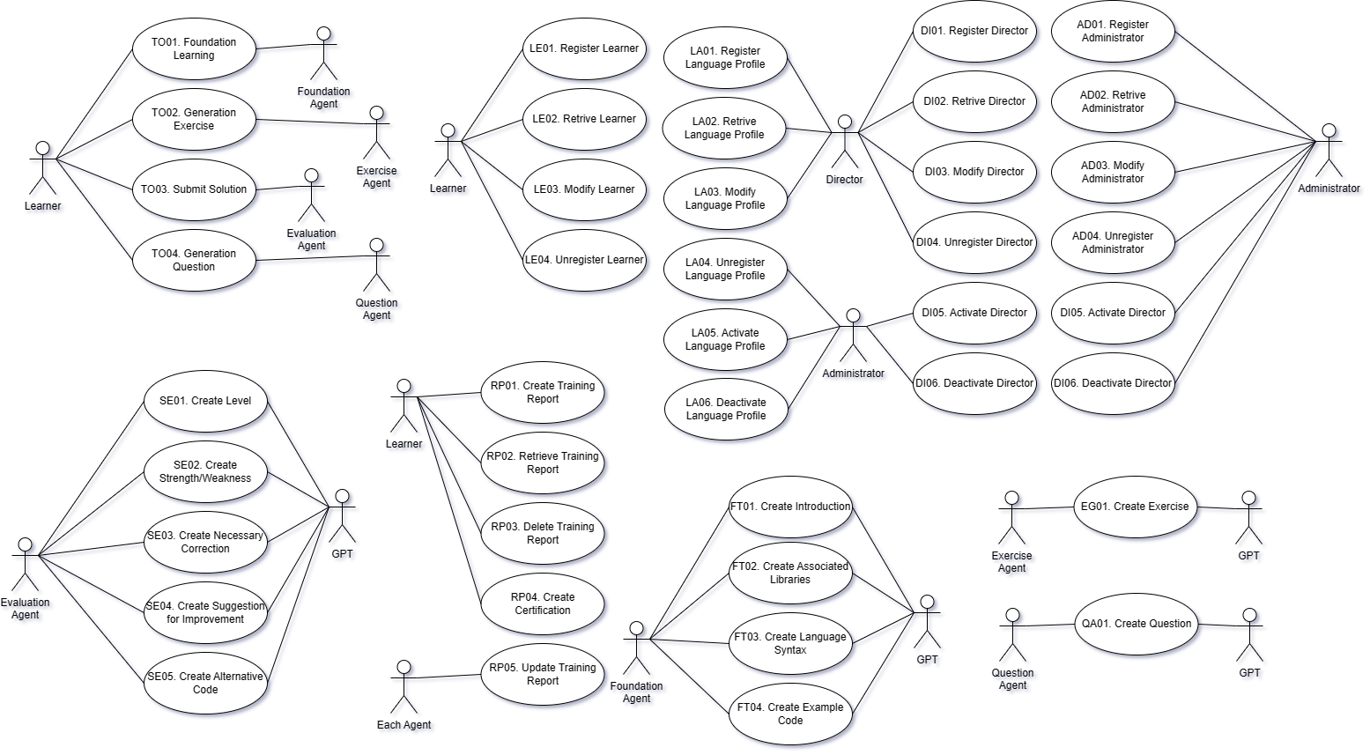

Figure 5. Use Case Diagram for the Functional Context

[Step 3] Information Context

### Representing the Information Context

The information context of the system shows the datasets manipulated by the system. Class Diagram can be effectively used to capture the information context.

In this context-level class diagram, we only show the entity-type classes, their relationships, and the cardinalities. No need to specify attributes and methods at this stage.

### Identifying Persistent Object Classes

Persistent object classes of the target system can be the following types of classes.

* Classes for Physical Objects
* Classes for Logical Objects
* Classes for Session-related Objects

### Context-level Class Diagram

The class diagram for acquiring the information context consists of only classes and their relationships. A relationship is defined with cardinalities.

The context-level class diagram of the target system is shown in Figure 6.

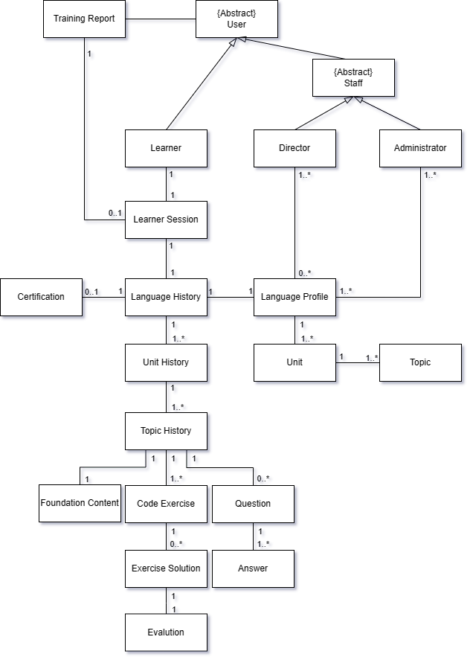

Figure 6. Class Diagram for showing Information Context

* Relationships

Various types of relationships are defined between classes.

* Cardinalities

Cardinalities are defined on every relationship.

## [Step 4] Behavioral Context

Behavioral context of the system shows the execution and control flow at runtime. Behavioral context may be more important for systems with complex workflows, parallel processing, and timing constraints.

### Representing the Behavior Context

Activity Diagram of UML provides a rich set of constructs that can be used to model the runtime behavior of the system.

### Allocate Functionality over Tiers

This task is to allocate the system functionality over the tiers. Use the table of functionality allocation as in Table 3.

Since the target system runs as a single tier, there is NO need to allocate on tiers.

Table 3. Allocation of Functionality over Tiers

|  |  |
| --- | --- |
| Tiers  Functional Groups | **Coding Trainer** |
| Learner Profile Management (LE) | ✓ |
| Director Profile Management (DI) | ✓ |
| Administrator Profile Management (AD) | ✓ |
| Language Profile Management (LA) | ✓ |
| Foundation Teaching (FT) | ✓ |
| Exercise Generation (EG) | ✓ |
| Solution Evaluation (SE) | ✓ |
| Training Report Generation (RP) | ✓ |
| Question Answer (QA) | ✓ |
| Training Operation (TO) | ✓ |

### Define Invocation Patterns

We define appropriate invocation patterns of the allocated functional groups. Each functional group is assigned with one or more invocation patterns. The common types of invocation patterns are Explicit Invocation, Event-driven, Timer-based, and Closed Loop.

The event-driven invocation may occur in two different ways:

* **Event I** is for handling events within a tier, i.e., intra-tier event-driven invocation.
* **Event II** is for handling events among multiple tiers, i.e., inter-tier event-driven invocation.
* This is not appliable to 1-tier system.

The invocation patterns defined on the functional groups is shown in Table 4.

Table 4. Invocation Patterns defined for Functional Groups

|  |  |
| --- | --- |
|  | **Coding Trainer** |
| Learner Profile Management (LE) | Explicit |
| Director Profile Management (DI) | Explicit |
| Administrator Profile Management (AD) | Explicit |
| Language Profile Management (LA) | Explicit |
| Foundation Teaching (FT) | Event I, C-Loop |
| Exercise Generation (EG) | Event I, C-Loop |
| Solution Evaluation (SE) | Event I, C-Loop |
| Training Report Generation (RP) | Event I, C-Loop, Timer |
| Question Answer (QA) | Event I, C-Loop |
| Training Operation (TO) | Explicit |

Now, the control flow of the target system can be well modeled based on the specified invocation patterns.

### Context-level Activity Diagram

Based on the invocation patterns defined over the tiers, we draw an activity diagram for each tier in the system as shown in Figure 7.

* Control Flow of Coding Trainer

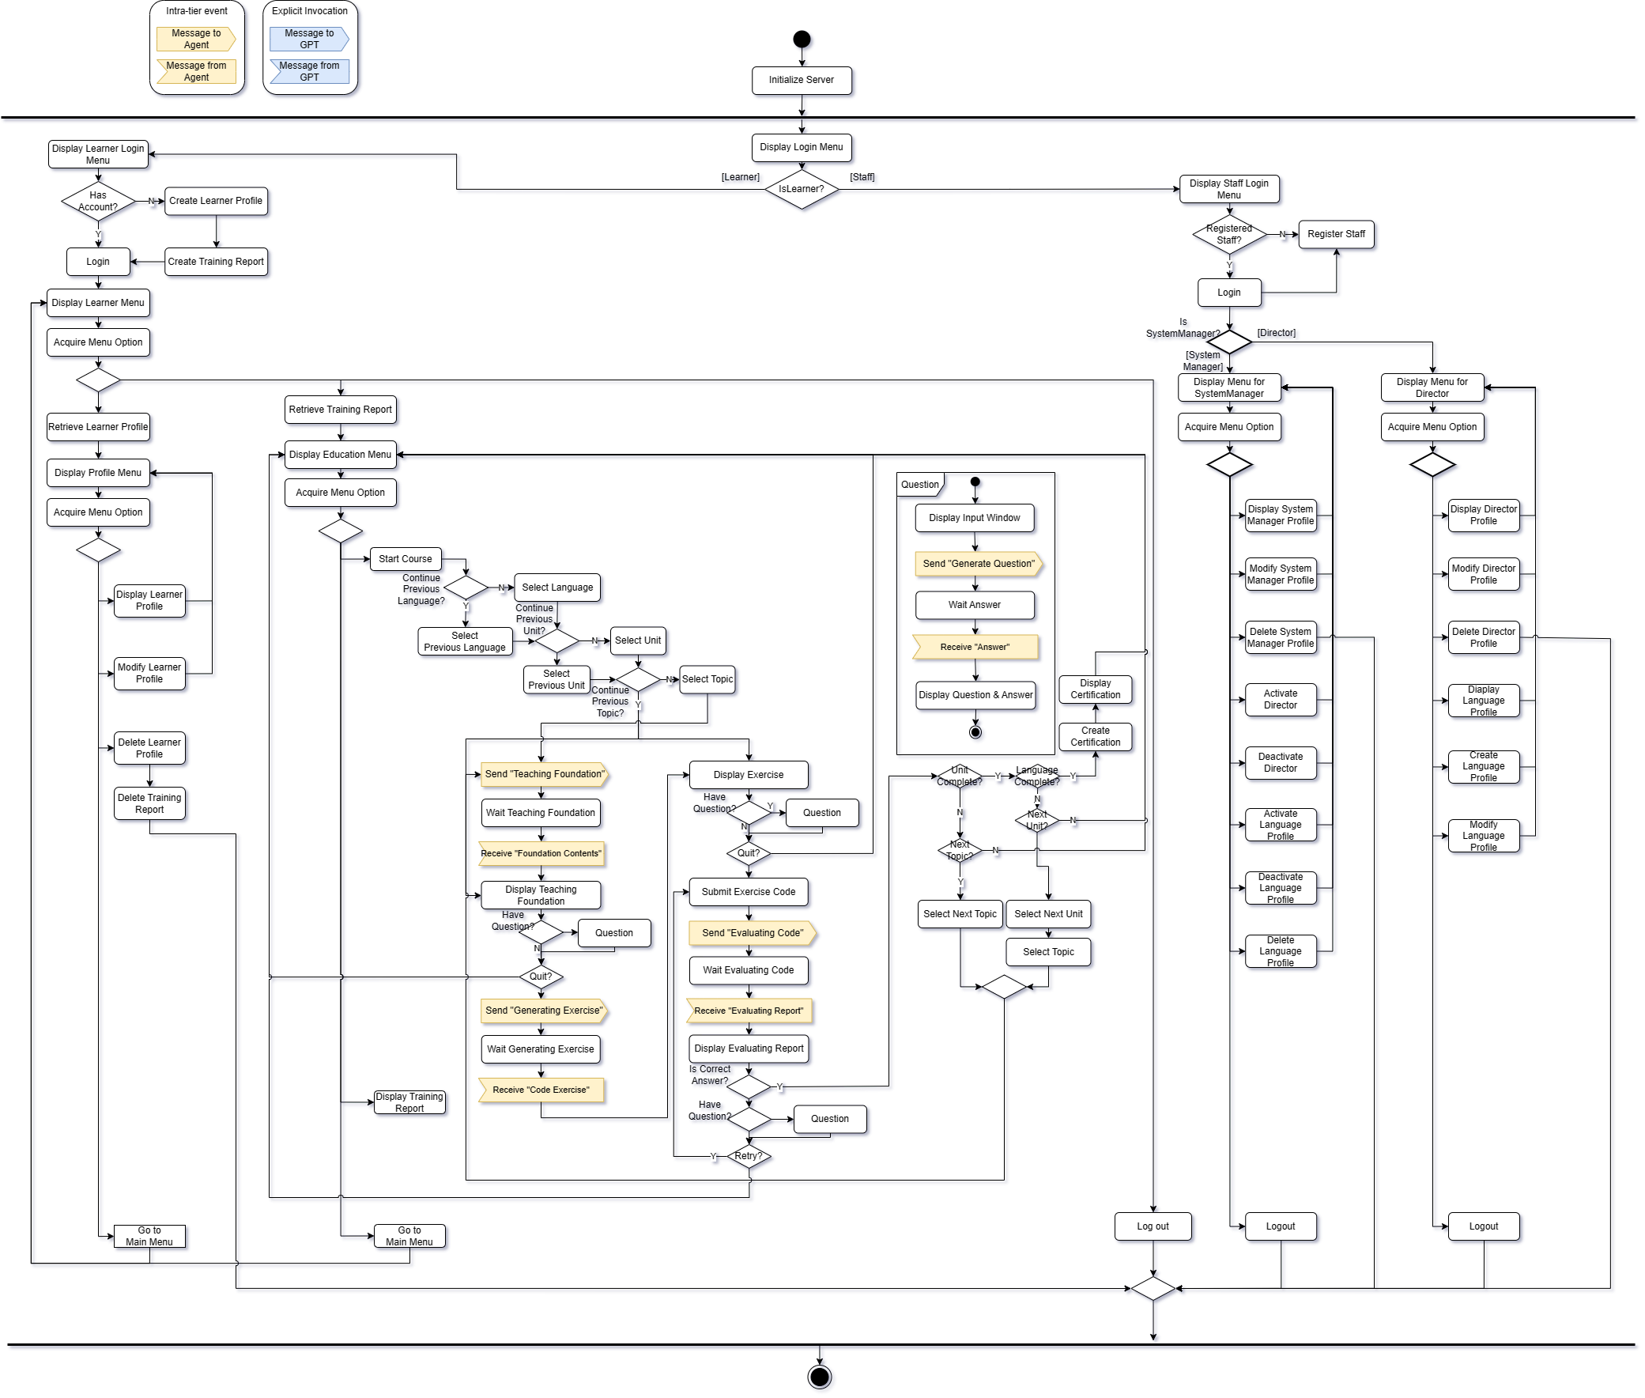

Figure 7. Activity Diagram for showing Behavior Context of System

The control flow begins with initialize process. Then, it runs 5 parallel threads.

* The thread #1 is to handle the functionality with explicit invocation pattern using a menu.
* The Thread #2~#5 are SW agent as shown in Figure 8.

The behavior context shows all the functionality of the system as defined in its functional context. That is, all the use cases of the system are reflected in this activity diagram.

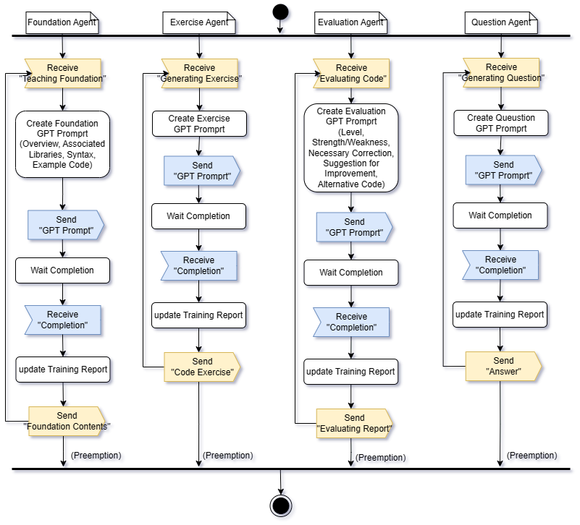

Figure 8. Activity Diagram for showing Behavior Context of SW Agent

* All Agents operate event-driven.
* Foundation agent and Exercise Agent build GPT-Prompt based on Topic in Language profile.
* Evaluating Agent builds GPT-Prompt based on submitted code.
* Question Agent builds GPT-Prompt based on Learner’s Question.

## [Step 5] Additional Contexts

Any additional contexts of the target system can be described.

* None

# Activity 3. Schematic Architecture Design

A schematic architecture is a description of the structural aspect of the target system without fully describing the key components and their properties. It can be effectively derived by applying architectural style(s). Each architectural style is a named collection of architectural decisions that are applicable in a given development context.

[Step 1] Observe Architectural Characteristics

We make the following observation on the target and derive candidate architecture styles from the observation.

* System consisting with Distinct Roles 🡪 MVC Architecture Style

The Coding Trainer whole system consists of 3 distinct roles of presentation, business logic, and data persistency management.

* Considering Loosely-coupled Event Handling 🡪 Event-driven Architecture Style

The Coding Trainer server can be operated by several events. To handle the events, additional processes/threads in the background are essential.

* High Reliability on Server 🡪 Dispatcher Architecture Style

The Coding Trainer system needs a load balancing for a reliable server.

[Step 2] Candidate Architecture Styles

With the architectural observation on the target system, we propose the following architectural styles.

* MVC architecture style
* Event-driven architecture style
* Dispatch architecture style

## [Step 3a] Evaluating ‘Candidate 1. MVC Architecture Style’

The MVC architecture decomposed a system into View, Control and Model. Each role has different responsibilities in the system.

### Evaluate the Applicable Situations

|  |  |  |
| --- | --- | --- |
| **Applicable Situations** | **Match** | **Demands on the System** |
| The target system can be divided into 3 distinct roles of View, Control and Model. | 🔾 | Coding Trainer system consists of View for users, Control for its logic and Model data. |
| View and Control are frequently changed. | 🔾 | Coding Trainer system provides user program language contents for learning which may be changed frequently as userfriendly-format. |
| This system is used for presenting Model Data as number of different types of View. | 🔾 | Coding Trainer system has multiple type of User and each user interact with system with different view. |

### Evaluate the Benefits

|  |  |  |
| --- | --- | --- |
| **Advantages of the Style** | **Match** | **Benefits Applicable to the System** |
| The dependency of each layer is minimal; depending on its immediately lower layer. | 🔾 | Each layer of Coding Trainer system should depend only on its immediate lower layer, reducing the dependency on other parts. |
| Various View are implemented with one Model. | 🔾 | Coding Trainer system provides different View for each types of Users with one Model. |
| Guarantee Synchronization of all independent View and Control. | 🔾 | Model changes immediately propagated to all Views and Controls and represented. |

### Evaluate the Drawbacks

|  |  |  |
| --- | --- | --- |
| **Cons of the Style** | **Match** | **Handling the Drawbacks** |
| Increase design complexity. | 🔾 | MVC introduces some extra classes/code due to the separation of model, view and controller. However, each functionality is distinct in the target system. |
| Difficulty of allocation functionality to appropriate component. | 🔾 | Coding Trainer system, each components’ role is clear. This problem is not expected. |
| Each View can be notified unexpected Model changes. Not all View has concern with Model changes. | 🔾 | This is not critical. The majority of Model changes are Learner related, so most of concern is about View, respectively, and it is essential. |

### Result of the Evaluation

MVC architecture style is well applicable to the target system according to the justification. There is no significant issue which prevents the application of this style.

## [Step 2b] Evaluating ‘Candidate 2. Event-driven Architecture Style’

The target system can be well configured with the Event-driven architecture style. This is applied Generating Coding Trainer’s Learning Contents.

### Evaluate the Applicable Situations

|  |  |  |
| --- | --- | --- |
| **Applicable Situations** | **Match** | **Demands on the System** |
| The system consists of event emitters and event sinks. Occurrence of events invoke specific functionality of events. | 🔾 | Coding Trainer system use various event signal to service specific functionality. |
| The communication between event emitter and event sinks is asynchronous, providing benefits of parallelism, modularity, and extendibility. | 🔾 | Coding Trainer system uses asynchronous event handling to have parallelism, modularity and extendibility. The communication between event emitter and event sinks is asynchronous. |
| Upon arrival, the event listener locates an appropriate event handler for the received event. | 🔾 | Components of Coding Trainer server processes the event in its way according to a service type. |

### Evaluate the Benefits

|  |  |  |
| --- | --- | --- |
| **Advantages of the Style** | **Match** | **Benefits Applicable to the System** |
| This style achieves high modularity through its asynchronous capabilities. | 🔾 | Separation between a part which invokes event and a part handles that event makes possible to implement independently and is helpful in analysis. |
| It is possible to process the event handling in parallel. | 🔾 | The target system handles the event listener in parallel by using an asynchronous thread |

### Evaluate the Drawbacks

|  |  |  |
| --- | --- | --- |
| **Cons of the Style** | **Match** | **Handling the Drawbacks** |
| Event-driven architecture pattern is a relatively complex pattern to implement, primarily due to its asynchronous distributed nature. | 🔾 | The number of event sources and sink sources are limited since the number of functionalities is small. |
| It is difficult to figure out cause of errors immediately and hard to understand whole system data control flow. | 🔾 | The Coding Trainer System does not complex event algorithm. The number of events is understandable. |

### Result of the Evaluation

Event-driven Architecture style is well applicable to the target system according to the justification. There is no significant issue which prevents the application of this style.

## [Step 2c] Evaluating ‘Candidate 3. Dispatcher Architecture Style’

The target system can be well configured with the Dispatcher architecture style. This is applied between Web Browser and Server for high QoS.

### Evaluate the Applicable Situations

|  |  |  |
| --- | --- | --- |
| **Applicable Situations** | **Match** | **Demands on the System** |
| The system adopts Dispatcher middle layer between client and server. | △ | The Coding Trainer System has performance impact. High QoS needs to meet for Stakeholder’s concern. Coding Trainer system has high demand of Load-balancing. |
| For high scalability and availability in Distributed environment, this system maintains multiple servers those are considered as One Server at Client. | 🔾 | The Coding Trainer system can have multiple Server with Dispatcher. |
| Need replicate Servers for Reliability | 🔾 | Need to have multiple servers for the NFR of availability. |

### Evaluate the Benefits

|  |  |  |
| --- | --- | --- |
| **Advantages of the Style** | **Match** | **Benefits Applicable to the System** |
| High Availability and Reliability | 🔾 | It is very important to minimize failure and data loss between operations. |
| High Performance | 🔾 | There will be a lot of service request from learner in the target system. The performance and QoS should be high. |

### Evaluate the Drawbacks

|  |  |  |
| --- | --- | --- |
| **Cons of the Style** | **Match** | **Handling the Drawbacks** |
| Difficulty of changing dispatcher interface | △ | The interface of Coding Trainer system would be fixed before deployment. When the change is happened, we can apply design pattern like adapter to fix interface mismatch. |
| Inefficient connection manner between client-dispatcher-server. It provides an explicit and bypass connection. | △ | This is not critical for the Coding Trainer system. Availability is more important. |

### Result of the Evaluation

Dispatcher Architecture style is well applicable to the target system according to the justification. There is no significant issue which prevents the application of this style.

## [Step 2e] List of Selected Architecture Styles

All the candidate architecture styles are chosen for defining the Schematic architecture.

* MVC Architecture Style
* Event-driven Architecture Style
* Dispatcher Architecture Style

## [Step 3] Applying Architecture Styles

We apply the selected architecture styles incrementally.

### Applying MVC Architecture Style

Coding Trainer Server are composed of MVC as shown in Figure 9.

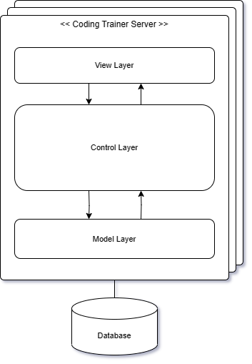

Figure 9. Applying MVC Architecture Style

* View Layer provides a GUI and performs simple functions related to user interaction.
* Control layer performs major business logic.
* Model layer provides an interface to access DB data.

### Applying Event-driven Architecture Style

For Coding Trainer Server, Event-driven Architecture Style is applied as shown in Figure 10.

Each user can request direct function execution through the displayed screen, which is included in the explicit invocation control layer.

According to Learner's direct function performance, the SW Agent performed in the background is designed to operate on an event basis.

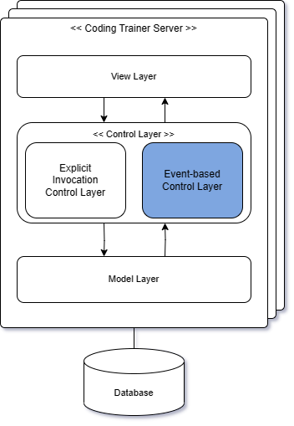

Figure 10. Applying Event-driven Architecture Style

### Applying Dispatcher Architecture Style

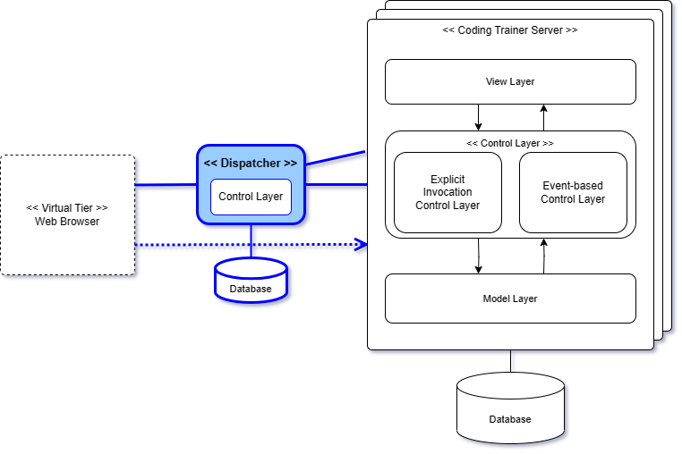

Figure 11. Applying Dispatcher Architecture Style

The system applied Dispatcher architecture style. Dispatcher located between Web Browser and Coding Trainer Server.

The coding trainer system itself is deployed as a web server, and there is no Client Tier with Control, but it has a Virtual Tier, a web browser, which connects users to the server in consideration of Load Balancing and QoS when accessing the server from the web browser. It is expected to behave like a router on the network.

### Resulting Schematic Architecture

The resulting Schematic architecture of applying all the selected architecture styles is shown in Figure 12.

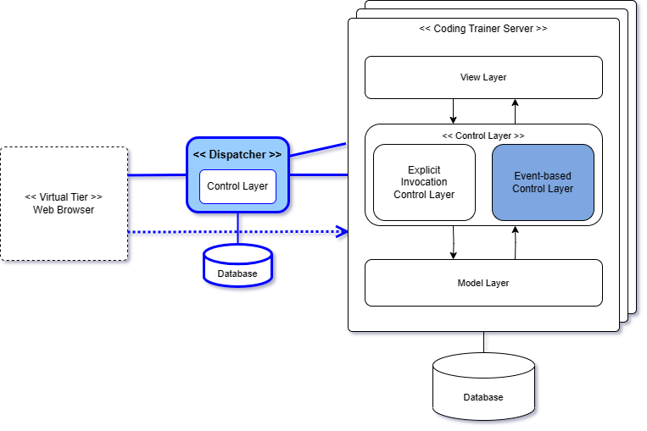

Figure 12. Resulting Schematic Architecture

The resulting architecture shows the application of the selected architecture styles. And it serves the stable basis on which view-specific architectural designs can be appended.

## [Step 4] Refining Interaction Paths

Define interaction paths among places in the Schematic architecture. An interaction path can be casual dependency or persistent relationship. It provides paths for making function calls or sending messages for communications among components.

### Interaction Paths derived from the Styles

All the interaction paths defined in each architecture style are adopted and remain unchanged in the Schematic architecture.

* Interaction Paths from MVC Architecture Style
* Interaction Paths from Event-driven Architecture Style
* Interaction Paths from Dispatcher Architecture Style

### Refinements on the Default Interaction Paths

* None

The target platform does not require refinements on the interaction paths. Therefore, the default interaction paths remain the same.

## [Step 4] Elaborating the Schematic Architecture

### Strengths

Specify the advantages of the proposed Schematic architecture.

* Separation of Concern

Each component or layer represents a unique and separate concern. It yields a logically well-defined architecture with high modularity.

* Complexity of the System Design and Implementation

Due to the independence of each component or layer, the complexity design is low, and effort to implement the system can be greatly reduced.

* High Maintainability

Due to the key principles applied to designing the Schematic architecture, the impact of modification would be minimal.

### Drawbacks

Specify the drawbacks and risks of the proposed Schematic architecture.

* Not Anticipated.

# Activity 4. View-specific Architecture Design

This chapter describes the results of applying essential architecture viewpoints. The Schematic architecture is now refined with additional architectural decisions made with viewpoints.

## Functional View

### [Step 1] Observe Functional Characteristics

We made the following observations on the system functionality.

* Functionality of Managing User Profiles

The target system has three kinds of user to manage; Learners, Director and Administrator.

* Functionality of Managing Language Profile
* Functionality of Foundation Teaching
* Functionality of Exercise Generation
* Functionality of Solution Submission
* Functionality of Solution Evaluation
* Functionality of Training Report Generation
* Functionality of Question Answer
* Functionality of Learner Session

### [Step 2] Refine Use Case Diagram

Before identifying functional components, we refine the context-level use case diagram with corrections and greater details. We first define the following functional groups for the target system.

* Functional Groups (from the SRS)
* Learner Profile Management (LE)
* Director Profile Management (DI)
* Administrator Profile Management (AD)
* Language Profile Management (LA)
* Foundation Teaching (FT)
* Exercise Generation (EG)
* Solution Submission (SS) (added)
* Solution Evaluation (SE)
* Training Report Generation (RP)
* Question Answer (QA)
* Learner Session (LS) (changed)
* Refined Use Case Diagram (Whole)

The following diagram shows the whole use case diagram. The refined use case diagram includes a number of enhancements and refinements over the context-level use case diagram as shown in Figure 13.

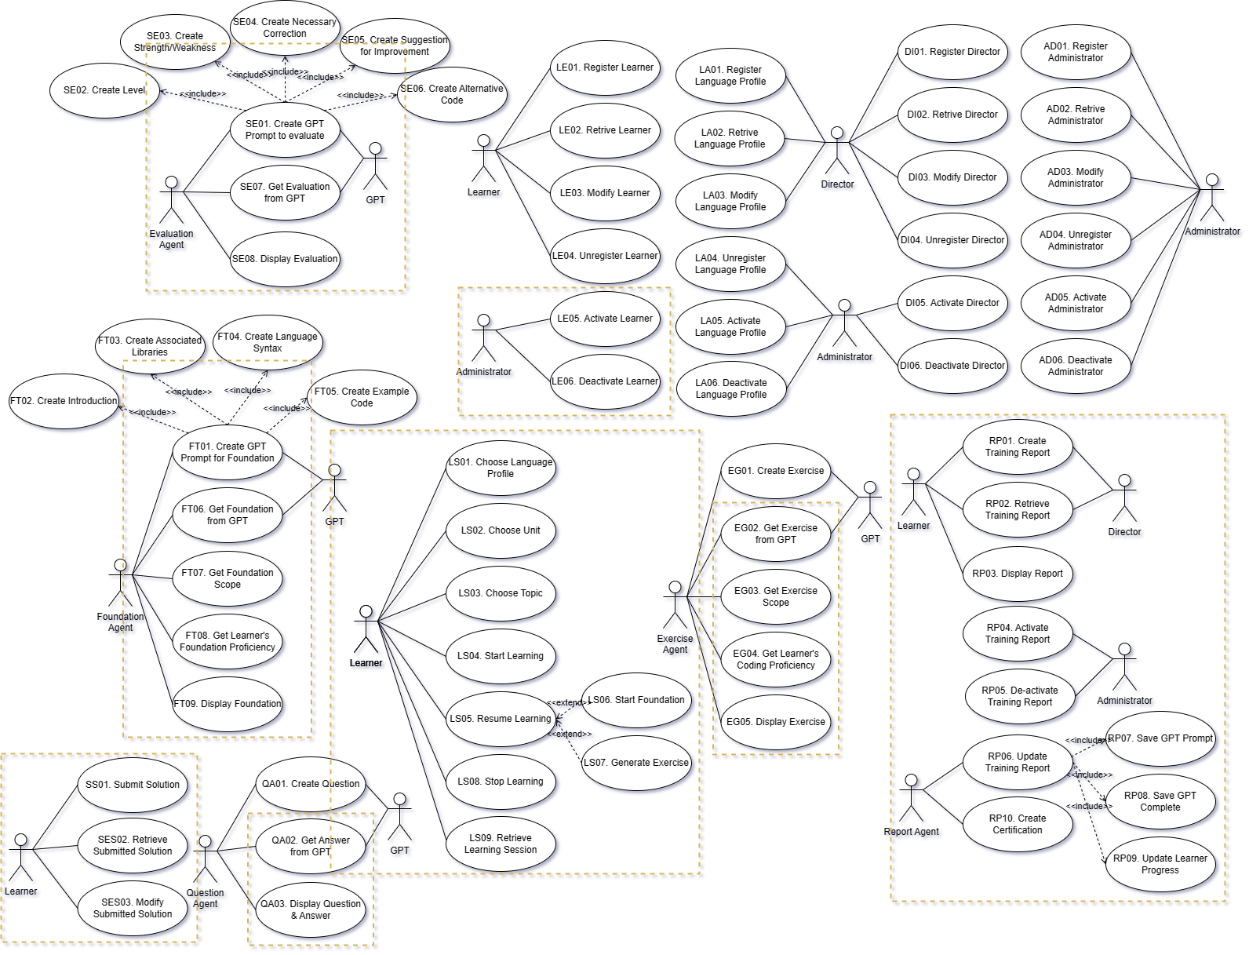

Figure 13. Refined Use Case Diagram

* Refinements made

The refinements made on the initial use case diagram are shown with rectangle markers.

* The Training Operation Group has been changed to Learner Session.
* Added Scope and Proficiency to be reflected in the Exercise Generation and Foundation Teaching group.
* The existing create use cases of Foundation Teaching and Solution Evaluation Group were changed to the include relationship of the GPT Prompt generation function.
* The set of 3 use cases for Solution Submission are now defined.
* The set of 10 use cases for Training Report Generation are now added.
* We refine Training Report Generation Group such as Saving GPT sessions, Updating Learner Progress.

### [Step 3] Derive Functional Components

There are three categories of functional components to consider.

* Category 1. Functional Components derived from the SRS

The functional components are mainly derived from the system-intrinsic functionality, which is well modeled in its use case diagram. That is, the functional components can be systematically derived by clustering relevant use cases.

* Category 2. Functional Components derived from Schematic Architecture

Schematic architecture is typically designed by applying architecture styles. An architecture style consists of components and connectors. Some of the components and connects may need to be modeled as functional components.

* Category 3. Interface-centric Functional Components

An interface-centric functional component specifies a stable and public interface, which will be realized/implemented.

The functional Components derived are shown in Figure 14.

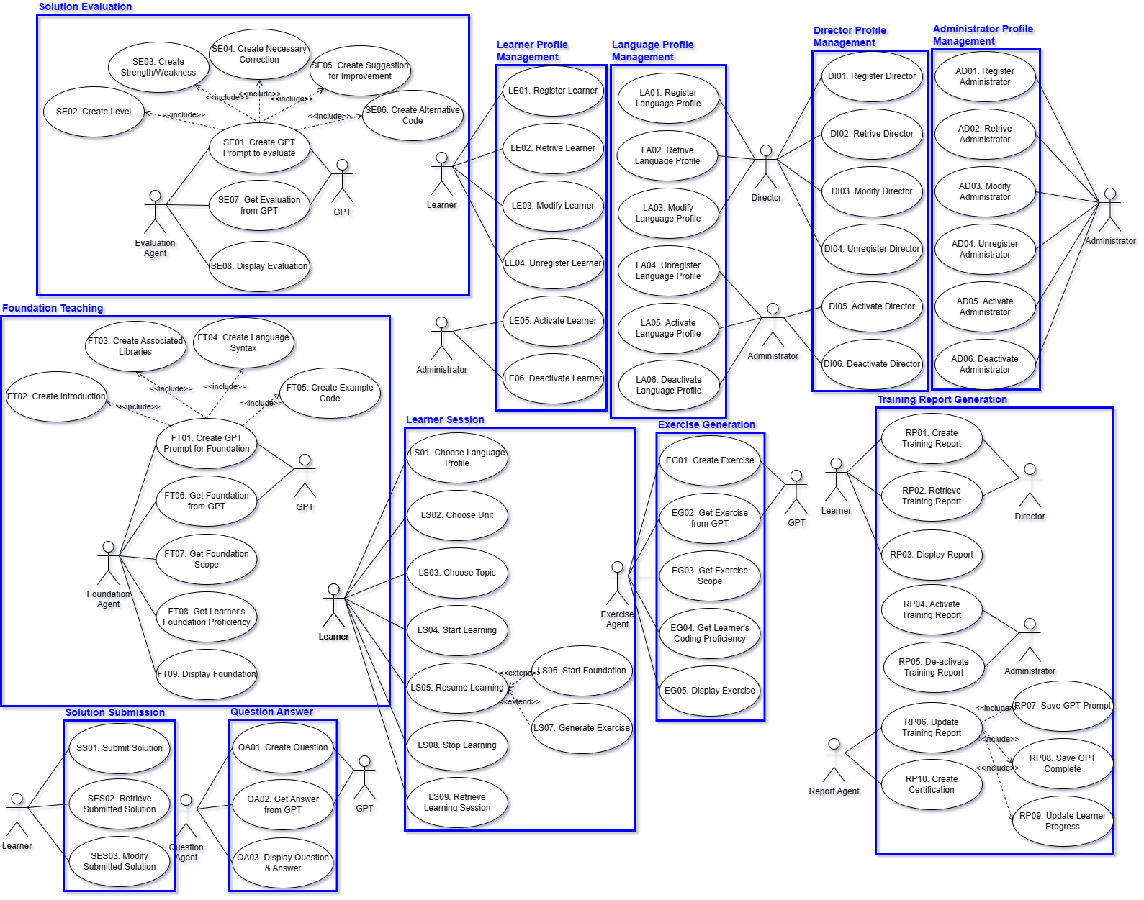

Figure 14. Deriving Functional Components

The summary of the functional components and their relevant use cases is shown in Table 5.

Table 5. Functional Components and their Use Cases

|  |  |  |
| --- | --- | --- |
| **Functional Components** | **Use Cases** | **# of Use Cases** |
| Learner Profile Management (LE) | LE01~LE06 | 6 |
| Director Profile Management (DI) | DI01~DI06 | 6 |
| Administrator Profile Management (AD) | AD01~AD06 | 6 |
| Language Profile Management (LA) | LA01~LA06 | 6 |
| Foundation Teaching (FT) | FT01~FT09 | 9 |
| Exercise Generation (EG) | EG01~EG05 | 5 |
| Solution Submission (SS) | SS01~SS03 | 3 |
| Solution Evaluation (SE) | SE01~SE08 | 8 |
| Training Report Generation (RP) | RP01~RP10 | 10 |
| Question Answer (QA) | QA01~QA03 | 3 |
| Learner Session (LS) | LS01~LS09 | 9 |
| Total # of Use Case | | 71 |

* Components derived from Architecture Styles

Table 6. Functional Components of Dispatcher Architecture Style

|  |  |
| --- | --- |
| **Functional Components** | **Use Cases** |
| Server Allocation Manager | QM01. Register Server  QM02. Evaluate QoS  QM03. Allocate Server |

The Coding Trainer System supports communication with the server through the web browser. At this time, the dispatcher structure is intended to be used for stable service support. The Web Browser communicates with the dispatcher first and receives the server assignment to proceed with the server.

* Interface Components

The target system does not have an interface-centric Functional Components.

### [Step 4] Refine Functional Components for Tiers

This step is to refine functional components on the tiers of Schematic architecture. Since the Schematic architecture of the target system has only one tier, this step is not applicable.

* Not Applicable

### [Step 5] Allocate Functional Components

This step is to find the Functionality Place Holders and allocate functional components onto functionality place holders in the Schematic architecture.

* Functionality Place Holders

A functional place holder is a layer, a partition, or any place which is defined to host some functionality. Often, the control layer of each tier becomes the functionality place holder.

The functionality place holders for the target system are shown in Figure 15.

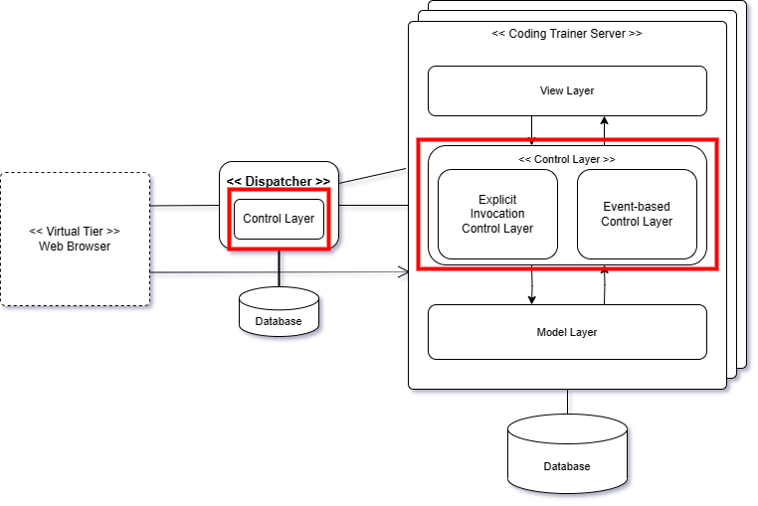

Figure 15. Functionality Place Holders of the Target System

* Allocating Functional Components

Since the Schematic architecture is defined with 1-Tier Architecture style, we assigned all functional components to server. However, Server Allocation Manager, a Functional Component by Architecture, was specifically assigned to Dispatch.

The classification of the functional components is shown in Table 7

Table 7. Partitioning Functional Components

|  |  |  |
| --- | --- | --- |
| **Place Holders**  **Functional Components** | **Cording Trainer Server** | **Dispatcher** |
| Learner Profile Manager | Learner Prof. Manager |  |
| Director Profile Manager | Director Prof. Manager |  |
| Admin Profile Manager | Admin Prof. Manager |  |
| Language Profile Manager | Language Prof. Manager |  |
| Foundation Teaching Generator | Foundation Teaching Generator |  |
| Exercise Generator | Exercise Generator |  |
| Solution Submitter | Solution Submitter |  |
| Solution Evaluator | Solution Evaluator |  |
| Training Report Generator | Training Report Generator |  |
| Question Answer Generator | Question Answer Generator |  |
| Learner Session Manager | Learner Session Manager |  |
| Server Allocation Manager |  | Server Allocation Manager |

As shown in the table, most functional components were assigned to servers, but Server Allocation Manager for distributed processing and stable server operation was assigned to Dispatcher to connect the appropriate server from Server Allocation Manager when connected through a web browser.

* Server Allocation Manager

Server Allocation Manager is like a router and is responsible for connecting connections to the optimal server. Due to the characteristics of the user accessing through the web browser, it is difficult to maintain a separate control and database, and the dispatcher integrates and manages the function. It will be possible to maximize the stability and efficiency of the service by playing the role of a Load Balancer even in the use of many users.

We now allocate the refined functional components on the functionality holders according to the table of refined functional components, as shown in Figure 16.

Each place holder is defined with its functional components. The Schematic architecture is now more complete with functional components.

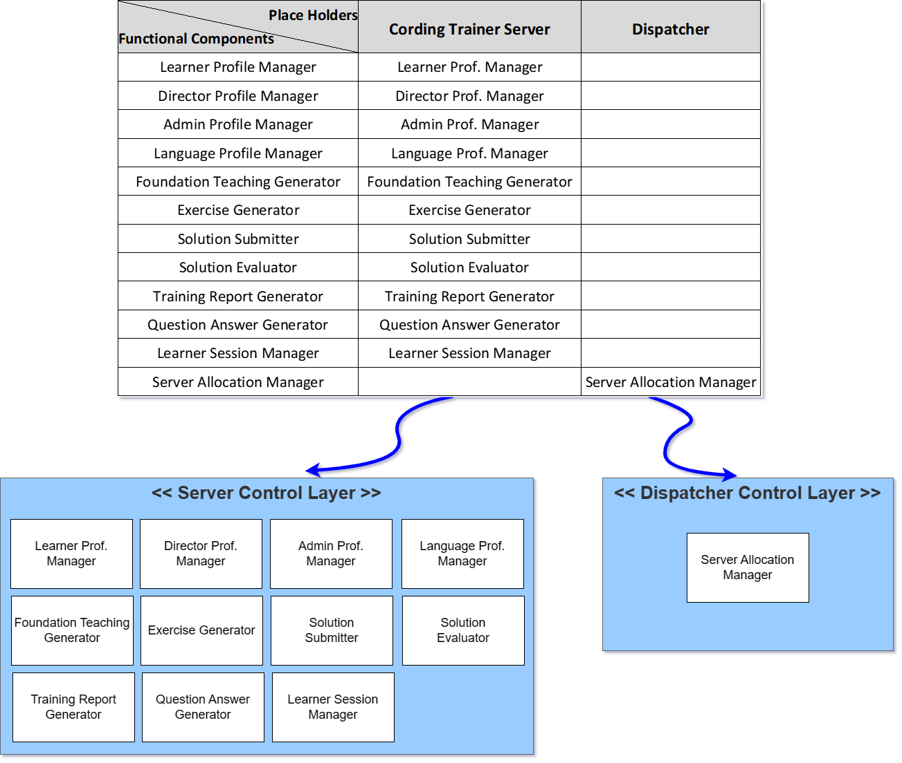

Figure 16. Allocaiton of Components on Functionality Place Holders

### [Step 6] Design Functional Components

Each functional component must be designed in greater detail. There are different options for designing functional components in detail. We use the following criteria for determining the type of each functional component.

* Criterion 1. Visibility of Functional Component

Whitebox Component or Blackbox Component

* Criterion 2. Type of Interface (for Blackbox Components)

Façade-type or Mediator-type

* Criterion 3. Variability of Functional Component

Closed Component or Open Component

* Criterion 4. Variation Points (for Open Component)

Variation points where the variability occurs.

We use the table of Functional Component Design Decisions as shown in Table 8.

Table 8. Design of Functional Components

|  |  |  |  |  |
| --- | --- | --- | --- | --- |
| **Refined Functional Components** | **Visibility** | **Interface Type** | **Open/Closed** | **Variant Points** |
| Learner Profile Manager | Blackbox | Façade | Closed | N/A |
| Director Profile Manager | Blackbox | Façade | Closed | N/A |
| Admin Profile Manager | Blackbox | Façade | Closed | N/A |
| Language Profile Manager | Blackbox | Façade | Closed | N/A |
| Foundation Teaching Generator | Blackbox | Façade | Closed | N/A |
| Exercise Generator | Blackbox | Façade | Closed | N/A |
| Solution Submitter | Blackbox | Façade | Closed | N/A |
| Solution Evaluator | Blackbox | Façade | Closed | N/A |
| Training Report Generator | Blackbox | Façade | Closed | N/A |
| Question Answer Generator | Blackbox | Façade | Closed | N/A |
| Learner Session Manager | Blackbox | Façade | Closed | N/A |
| Server Allocation Manager | Blackbox | Façade | Closed | N/A |

* Blackbox Components

All the functional components derived from the SRS are defined as the type of blackbox component for reusability and maintainability.

* Whitebox Components

None

* Components with Openness

The components with openness shows the variability and hence they are designed with open-design schemes.

### [Step 7] Define Interfaces of Functional Components

A functional component provides its functionality through a *provided* interface. A functional component with ‘open’ design may also need a *required* interface if it accepts a pluggable object as a variant. Note that the ‘Required Interface’ is only one of various ways of designing components with openness.

However, we do not describe the contents because there is no use of open-type components in our target system.

## Information View

Architecture design for Information View is to make decisions about persistent datasets, properties, and their management. This activity includes a number of tasks including identifying data components, allocating data components, defining their data contents, ownership, data distribution, replication, migration, data security, and data timeliness.

### [Step 1] Observe Informational Characteristics

We first observe the informational characteristics of the target system.

* Adding Session-related Classes
* Refining Relationships for various Conceptual Object Classes

### [Step 2] Refine Persistent Object Model

In object-oriented paradigm, persistent datasets are modeled as entity-type classes. Hence, we refine the context-level class diagram with greater details, which becomes the basis for deriving data components.

* Refined Class Diagram

The revised class diagram shows additional classes and refined relationships as shown in Figure 17. Note that attributes are omitted in this sample solution.

The refined class diagram shows refinements in colors.

* The class used for the previous training report has been changed to Learner Session. Also, I changed the term from Progress to Learning History.
* At the same time as Learner's registration, a Training Report is generated to maintain a one-on-one relationship. This ensures the Learner's behavior to the Training Report.
* The Learner Session includes all Language History, Unit History, and Topic History so that you can include all of the history of language learning.
* Language History contains ordered content based on the Language Profile.
* Administrators have more accessible components than ever before.
* GPT-4 Session added. To overcome the limitations of short-term session of GPT, all information of Foundation Content, Excellence, Evaluation, and Q&A generated through GPT can be recorded.
* Refinements on Relationships
* Relationships between Training Report and *User type*.
* Relationships between Administrator and Director.
* Relationships between Administrator and Learner.
* Relationships between Learner Session and Language Learning History.
* Relationships between Language Learning History and Unit Language History.
* Relationships between Topic Learning History and Each Learning Contents.
* Each class is specified with a textual description.

Omitted in this sample solution.

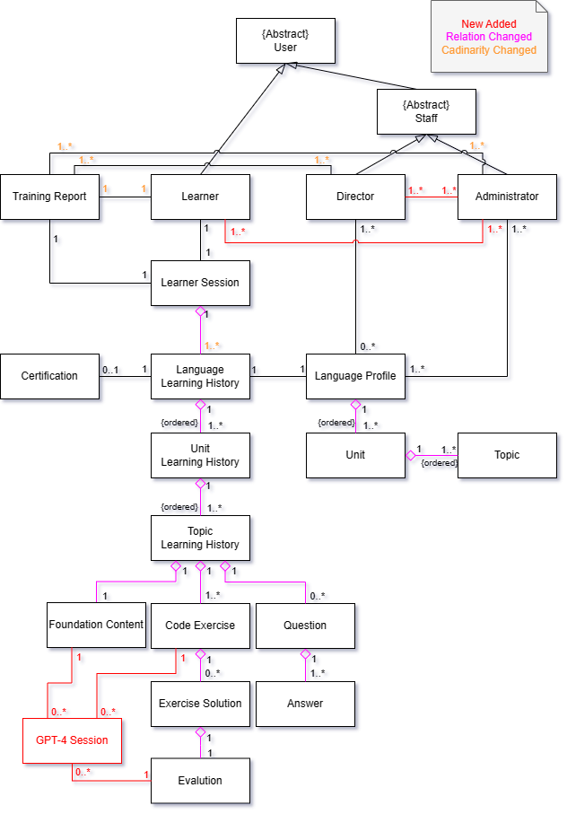

Figure 17. Refined Class Diagram

### [Step 3] Derive Data Components

By considering the strengths of inter-class relationships, we group a set of related classes into a data component as shown in Figure 18.

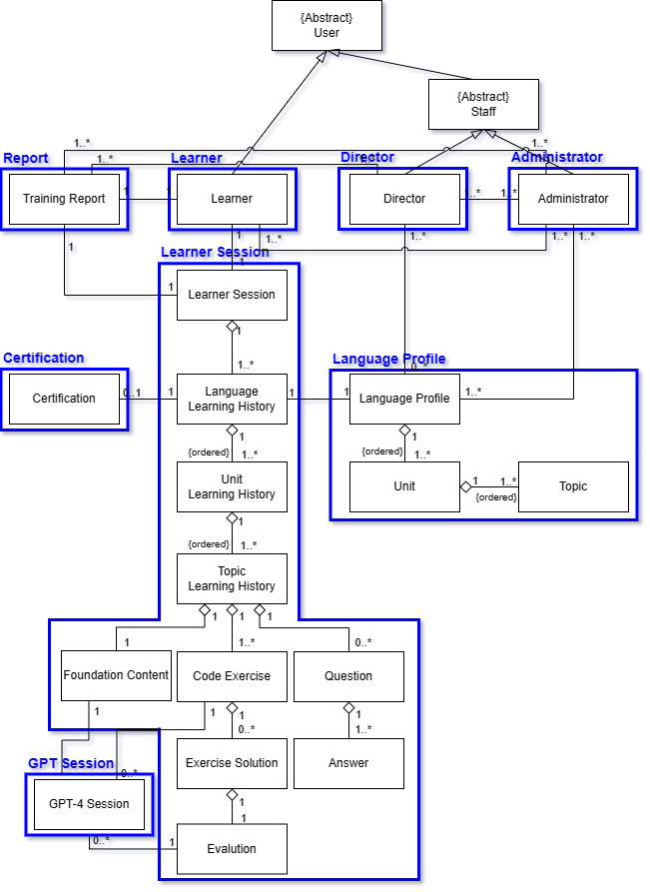

Figure 18. List of Data Components

As shown in the figure, classes with strong dependency such as inheritance and compositions are grouped into the same data component. The data components that are derived by considering the strengths of relationships among classes.

* Data Components derived from Architecture Style

None

### [Step 4] Refine Data Components for Tiers

The Schematic architecture of the target system has multiple tiers, and hence we need to refine them for the tiers. Table 9 shows the allocation of data components on tiers.

* In fact, the Coding Trainer System has only one tier.

Table 9. Data Components allocated on Tiers

|  |  |
| --- | --- |
| **Tier**  **Data Components** | **Coding Trainer Server** |
| Learner | Learner |
| Director | Director |
| Administrator | Administrator |
| Language Profile | Language Profile |
| Learner Session | Learner Session |
| Report | Report |
| Certification | Certification |
| GPT Session | GPT Session |

* Considering the Consistency with Allocation of Functional Components

The allocation of data components is well aligned with the allocation of functional components. Hence, the inter-tier access between functional components and data components is not presented.

### [Step 5] Allocate Data Components

Allocate the data components to the appropriate place holders of the architecture. The data component holders for the target system are shown in Figure 19.

* Place Holders for Data Components

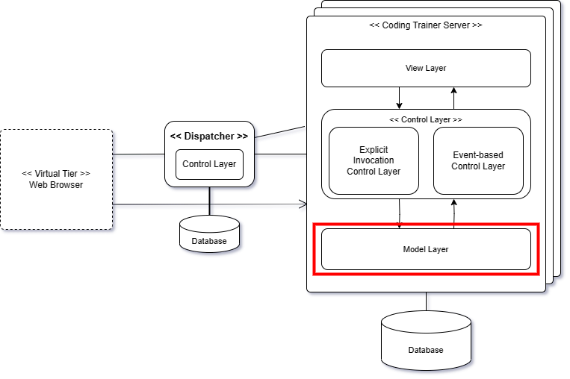

Figure 19. Data Component Holders of the Target System

There is only one data component holder in the system: *Model Layer*.

We now allocate the data components on the data component placeholders. We use the table of refining data components over tiers as shown in Figure 20.

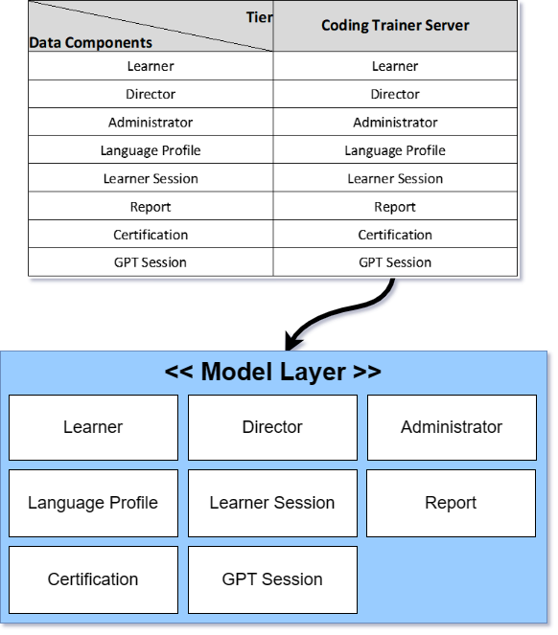

Figure 20. Allocation of Data Components

The allocation of data components is made according to the table for ‘Data Components Refinement’. Each model layer is allocated with an appropriate set of data components.

### [Step 6] Design Data Components

This step is to design the internal details of data components. This is trivial since each data component consists of classes and each class is defined with persistent attributes.

* Omitted in Sample Solution

### [Step 7] Define Interfaces of Data Components

This step is to define the interface of each data component. The interface for data components is mostly for CRUD-type data manipulation.

* Omitted in Sample Solution

## Behavioral View

The behavioral view of the architecture describes the dynamic aspect of the system, focusing on the runtime behavior of the system.

### [Step 1] Observe Behavioral Characteristics

The observations made in the behavioral context are applicable in this view-level design. The system behavior exhibits the following invocation types.

The invocation patterns for functional groups are refined as shown in Table 10.

Table 10. Invocation Patterns defined for Functional Groups

|  |  |
| --- | --- |
|  | **Coding Trainer System** |
| Learner Profile Management | Explicit |
| Director Profile Management | Explicit |
| Administrator Profile Management | Explicit |
| Language Profile Management | Explicit |
| Foundation Teaching | Event-driven, Closed Loop |
| Exercise Generation | Event-driven, Closed Loop |
| Solution Submission | Explicit |
| Solution Evaluation | Event-driven, Closed Loop, Timer |
| Training Report Generation | Event-driven, Closed Loop |
| Question Answer | Event-driven, Closed Loop |
| Learner Session | Explicit |

Now, the control flow of the target system can be well modeled based on the specified invocation patterns.

### [Step 2] Refining Control Flow of the Platform

We design the overall control flow of the target system. This is done by refining the context-level activity diagram. If the target system has multiple tiers, each tier has its own control flow and the interaction between the tiers should also be designed.

All the use cases in the functional view are reflected in the activity diagram, and all the actions and activities have their corresponding use cases. Hence, the consistency between the use case diagram and the activity diagram is well-maintained.

The refined control flow of the platform is shown in Figure 21, Figure 22.

* Refinements made on the Control Flow
* The system starts and selects whether it is Staff or Learner to proceed with Login. A different View will be shown for each User Type.
* In the case of Learner, a training report was generated with the register step so that it could have all of Learner's Language Study History.
* When you enter the Education Menu, you decide whether to proceed with the previous session or choose Language, Unit, and Topic, and proceed with the learning. If you select the previous session, you start with the previous breakpoint, and if you select Topic, you continue learning if you have a previous learning record, or you start with Foundation Teaching.
* A procedure has been added to take into account the scope for the Learner's proficiency and learning efficiency when creating personalized Foundation Content and Exercise.
* Solution submission was separated from the learning process and changed to be executed through the menu. After the solution is submitted, Evaluation Agent is designed to perform all the contents. Evaluation Agent is designed to determine whether to use GPT, notify the user of the completion of the evaluation after processing immediately if it can be processed immediately, and conduct the evaluation in the background for the submitted history of the solution that has not been processed.
* Each agent uses GPT using the GPT API, and is designed to store GPT Session and Learner's learning history by delivering an event to the Report Agent every cycle. When all learning of Language is completed, the report agent judges and creates a certification, and the user can check the training report in real time in the Display Training Report.

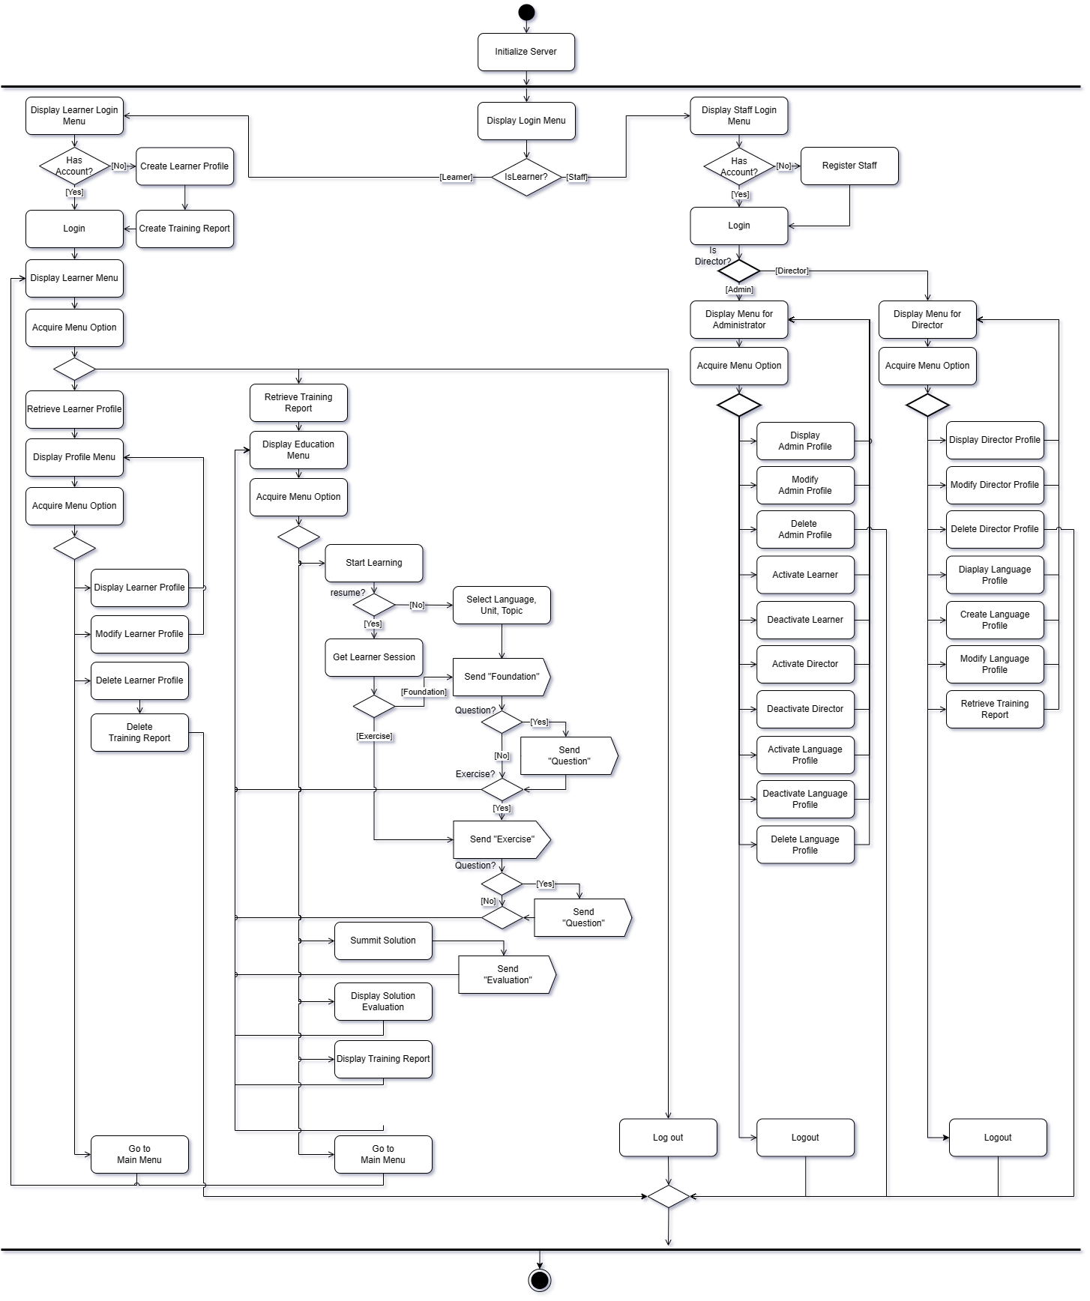

Figure 21. Refined Control Flow of Explicit Functional Group

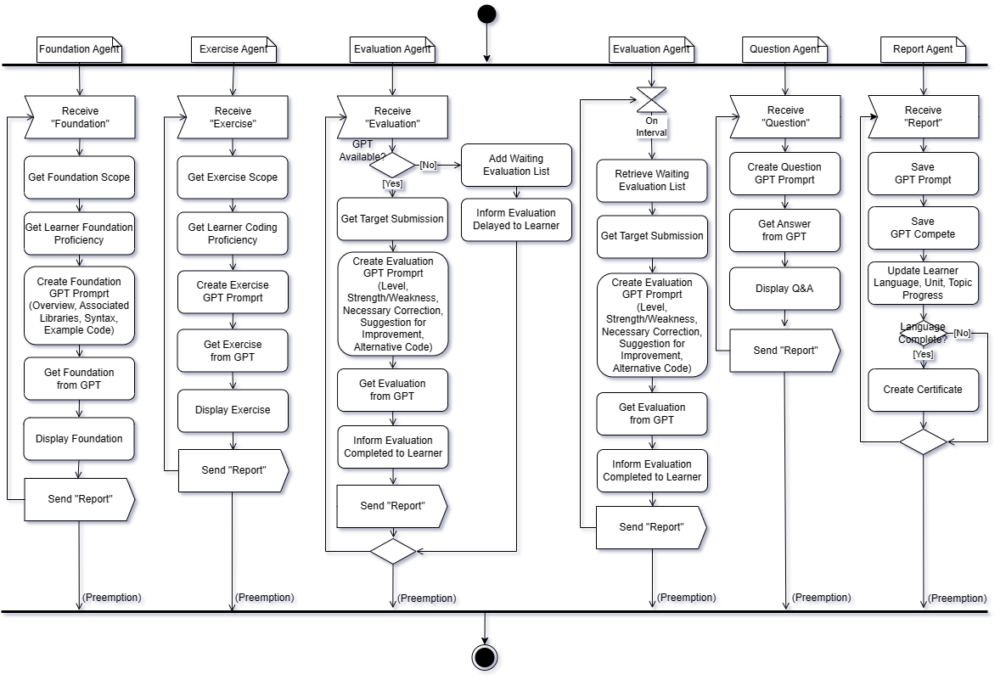

Figure 22. Refined Control Flow of SW Agent(Event-based, Timer)

### [Step 3] Choosing Element for Detailed Control Flow

In this step, we choose the functionality with complex control flows. That is, we chose use cases in Use Case Diagram, functional components, or actions and/or activities in Activity Diagram. Then, we perform a detailed behavior design for each element chosen.

For the target system, we choose the following elements for detailed control flow as shown in Figure 23.

* Use case, SE01. Create GPT Prompt to evaluate.

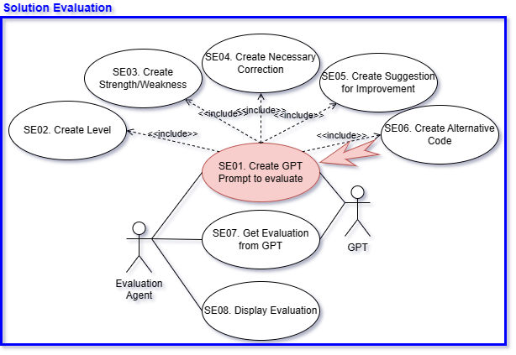

Figure 23. Target Element for Designing Detailed Control Flow

### [Step 4] Detailed Control Flow for ‘Create GPT Prompt to evaluate.’

* Functionality

This functionality is to make GPT Prompt to evaluate the program code submitted by learners and provide comprehensive feedback on the content submitted. Expected GPT Completion, evaluation should present accuracy, efficiency, compliance with coding standards, and other relevant criteria.

In order to deliver accurate evaluation to learners, GPT Prompt must be generated in detail and the service must be requested through the GPT API to receive the intended evaluation.

* Activity Diagram

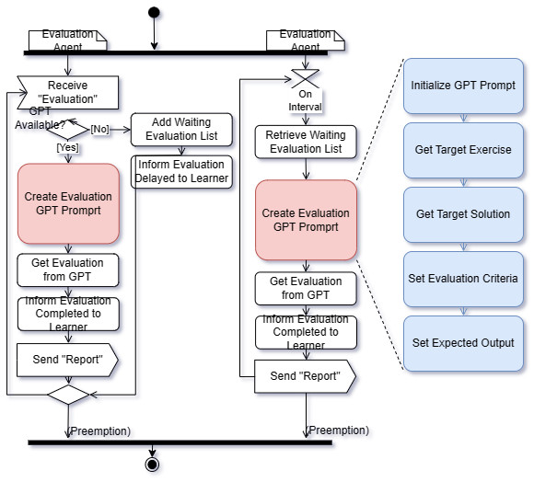

Figure 24. Detailed Control Flow of Create Evaluation GPT Prompt

* Input
* Target Exercise’s Conditions and Constraints

ex) time or space complexity limit

* Learner’s Target Solution
* Evaluation Criteria

ex) Accuracy, Efficiency, Readability, Exception Handling

* Expected Output

ex) Level, Strength/Weakness, Necessary Correction, Suggestion for Improvement, Alternative Code

* Output
* GPT Prompt

An accurate and detailed GPT Prompt should be created to evaluate the learner's solution.

* Precondition
* GPT is Available.
* Target Exercise is existed.
* Target Solution is existed.
* Begin

//Step 1. Initialize GPT Prompt.

Initialize GPT Prompt.(“Evaluate the learner's solution for exercise based on the following criteria.”)

//Step 2. Set Target Exercise’s Conditions & Constraints

GPT Prompt Add(Get Target Exercise)

GPT Prompt Add(Conditions & Constraints)

//Step 3. Set Target Solution

GPT Prompt Add(Get Target Solution)

//Step 4. Set Evaluation Criteria

GPT Prompt Add(“Please evaluate the level according to the Criteria below. The range is from 1 to 10, and the higher the level, the closer it is to 10.”)

GPT Prompt Add(“Accuracy, Efficiency, Readability”)

//Step 5. Set Expected Output

GPT Prompt Add(“Please make a Complete including the contents below.”)

GPT Prompt Add(“Strength/Weakness, Necessary Correction, Suggestion for Improvement, Alternative Solution)

End

* Postcondition

Use the service through GPT API with the generated GPT Prompt

* Example

Evaluate the learner's solution for exercise based on the following criteria.

[Exercise]

Print out Hello world.

[Condition]

Use standard input and output

[Constraints]

N/A

[Solution]

Print(“Hello World”)

[Criteria]

Evaluate the Accuracy Level. Range is 0 to 10 and the Higher it is, the closer it is to 10.

Evaluate the Efficiency Level. Range is 0 to 10 and the Higher it is, the closer it is to 10.

Evaluate the Readability Level. Range is 0 to 10 and the Higher it is, the closer it is to 10.

[Expected Output]

Please make a Complete including the contents below.

Strength/Weakness, Necessary Correction, Suggestion for Improvement, Alternative Solution.

## Deployment View

Deployment view of the architecture is concerned with the topology of software components on the physical layer, as well as the physical connections between these components.

### [Step 1] Observe Deployment Characteristics

* Programming Languages to support

Coding Trainer System will initially be available for Python implementations.

* Python
* Execution Environment

The execution environment will depend on the programming language.

* For Python implementation
* Operating System
* Ubuntu
* The Coding Trainer Server will be realized with a number of replicated medium-sized servers. The number of server instances can initially be determined with an estimation of peak-time load. If the number of users increases a lot, it will be expanded.
* The Dispatcher tier will be realized with a single high-end server since its functionality is not complex.

### [Step 2] Define Nodes

The Schematic architecture of the target systemconsists of double nodes. Each node is configured with a hardware specification and its execution environment.

* Node 1. Coding Trainer Server
* Hardware Specification
* High-end CPU with a minimum of 10 cores
* Execution Environment
* Operating System: Ubuntu 22.04
* Development Language: Python
* Node 2. Dispatcher
* Hardware Specification
* CPU with Moderate Computing
* Execution Environment
* Operating System: Ubuntu 22.04

### [Step 3] Define Network Connectivity

* Between Web Browser and Coding Trainer Server: HTTP-based network
* Between Server and Archival Server: HTTP-based network

### [Step 4] Define Artifacts to Deploy

* Artifacts for Coding Trainer Server
* Functional Components specified in Functional View-design
* Data Components specified in Information View-design
* Artifacts for Dispatcher
* Functional Components specified in Functional View-design
* Data Components specified in Information View-design

### [Step 5] Allocate Artifacts on Nodes

This step is to allocate all the deployable artifacts and show the network connections.

* Deployment for Python version

We use a Deployment Diagram to represent the nodes and artifacts as shown in Figure 25.

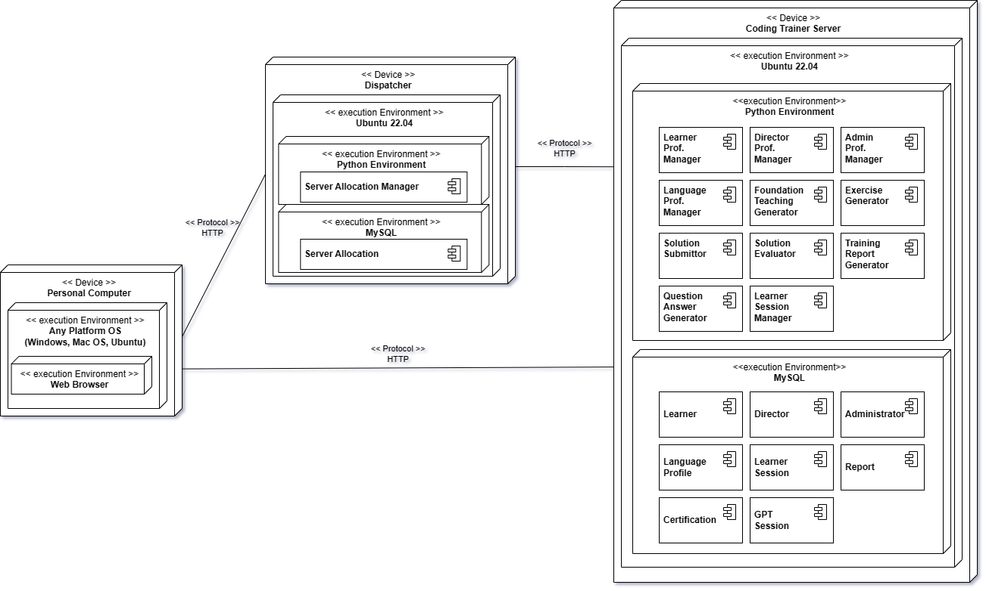

Figure 25. Deployment Diagram for the Target System

* Deployment for Java version

Omitted in this sample solution.

# Activity 5. NFR-specific Architecture Design

This chapter shows the architectural design for the given NFRs. The following process is used for applying NFR-based design.



## Design for High Reliability of the System

The target system provides services potentially to a large number of users, and hence the system should be designed to provide high-level reliability.

By emphasizing reliability in the design process, the system can effectively mitigate potential failures, minimize downtime, handles various faults, recovering efficiently from failures, and enhance the overall user experience.

Reliability in ISO 9126 is defined with three sub-quality attributes, and they should be satisfied by the system.

* Maturity
* Fault Tolerant
* Recoverability

### [Step 1] Identify Facts and Policies

Given the NFR of Platform Configurability, we can reasonably establish the following facts.

* (F1) High Coverage of Platform

By examining the given requirement in its entirety, we can conclude that a platform with high coverage will enhance its configurability, allowing it to accommodate a broad range of anomaly management applications.

…

### [Step 2] Define Criteria for Tactics

* (C1) Modeling the Scope of Platform (Relevant to F1)

The platform should be designed by analyzing the commonality among various anomaly management systems and reflecting the commonality in the platform design.

* (C2)

### [Step 3] Define Candidate Tactics

The following tactics are proposed for the identified criteria.

* (T1) Commonality Analysis for the Platform Scope (Relevant to C1)

Commonality analysis in software design is a process used to identify common requirements or features that can be shared among multiple software systems or components. It is a technique that helps software designers and developers to identify the similarities and differences among different applications or systems, and to determine the most efficient way to reuse or adapt existing components.

* Apply Commonality Analysis of Product Line Engineering

Commonality analysis is often used in the context of software product line engineering, where a family of related software products is developed using a common set of features and components.

* Step 1. Define the common features among various anomaly management systems.
* Step 2. Identify the common features that exhibit variability within the features.  
  Note that a common feature may not exhibit any variability.
* Step 3. Define variation points in each of common features revealing variability and identify variants for each variation point. Some of the features with variability are already provided in the SRS.

The application of this tactic results in the commonalty and variability (C&V) analysis of the platform.

* (T2) Apply Specialization for Manufacturing Domains (Relevant to C2)

There exists a number of well-known manufacturing domains and there could be additional manufacturing domains to be added after the platform is released. Hence, we need to apply the *open-scope* for this variation point.

We apply *Object* *Specialization* to define the taxonomy of various manufacturing plants. Some known manufacturing domains are pre-defined as concrete subclasses, and new manufacturing domains can be defined by subclassing an appropriate superclass. The design with object specialization is shown in the following figure.

* Benefits
* Extendibility 🡪 The hierarchy of manufacturing plants can flexibly be expanded with specializing appropriate classes.
* Reusability 🡪 The common attributes and methods can be defined in a class and its subclasses can inherit and reuse them, saving the development and maintenance effort.
* Customizability 🡪 In each subclass of a new manufacturing plant, adding additional attributes and methods can be added. Also, the inherited methods of a superclass can be overridden for the plant-specific features.
* Limitation
* Rebuilding the System 🡪 This tactic requires the rebuilding of the system whenever a new subclass is added.
* (T3) Apply Specialization, Association and Realization for Manufacturing Plants (Relevant to C3)

Manufacturing plants vary large on (1) manufacturing domain and (2) manufacturing region. Different regions typically have different laws, policies, industry regulations, standards, voltages, tax system, and environments including weather. Hence, we define an abstract class of ‘Manufacturing Plant’ and let it have associations with ‘Manufacturing Region’ and ‘Manufacturing Domain’.

* Specializing ‘Manufacturing Region’

The abstract class, Manufacturing Region’ can be specialized into different regions.

* Associations of ‘Manufacturing Plant’

An abstract class, Manufacturing Plant, is defined with two association relationships as shown in the following figure.

* Realization of ‘Manufacturing Plant’

Each manufacturing plant is defined by realizing ‘Manufacturing Plant’ class. Then, each manufacturing plant is linked to an instance of Manufacturing Region and an instance of Manufacturing Domain.

* Benefits

Each of the hierarchy, Manufacturing Domain and Manufacturing Region, can independently expanded and evolved without affecting each other. This enhances the extendibility and maintainability of the platform.

A new manufacturing plant can efficiently be defined by simply choosing links to the two instances.

* (T4) Apply a HAL layer for Hardware Devices (Relevant to C4)

This tactic is to define a Hardware Abstraction Layer (HAL) to accommodate the variability of hardware devices such as the APIs of hardware devices.

Hardware Abstraction Layer (HAL) is a layer of software that sits between physical hardware devices and the higher-level functional components that interact with it. The purpose of the HAL is to abstract away the low-level details of the hardware, providing a standard interface that can be used by higher-level software without needing to know the specific details of the underlying hardware.

* Interfaces of Hardware Devices in HAL

The three interfaces of HAL have already been defined in the functional view design. We add a new interface for ‘IoT device’ for its potential usages in manufacturing plants.

Note that each interface can be specialized into sub-types of the hardware. For example, the Sensor Interface can be specialized into different types of sensor interfaces such as Temperature Sensor interface, Humidity Sensor interface, Vibration Sensor interface, Light Sensor interface, etc.

* Benefits

A HAL layer provides a standardized interface that can be used by functional components regardless of the specific hardware devices they are running on. This makes it easier to develop software that can run on multiple platforms without needing to be modified for each individual platform.

HAL also helps to isolate higher-level functional components from the details of the hardware. This can make the system more modular and easier to maintain, as changes to the underlying hardware can be handled by updating the HAL without needing to modify the higher-level software components.

* (T5) Apply Specialization and Required Interfaces for Anomaly Types (Relevant to C5)

This tactic is to apply specialization for common and known anomaly types and required interfaces for accepting new Anomaly Types.

* Specialization of Anomaly Types

A hierarchy of anomaly types can be defined for known anomaly types, and its structure is similar to that of ‘Manufacturing Domain’.

* Required Interfaces for New Anomaly Types

A required interface in UML specifies a set of methods that must be implemented by other components to be able to work with the component that defines the interface. The methods in the required interface represent the expected behavior or functionality of the component, and therefore it is utilized as an open design scheme to accept variants in plugin-object form.

Note that the requirement interface, ‘irAnomaly Type’, defines the set of common methods that must be implemented by a class of new anomaly type. Once the class is implemented using the interface, an instance of the class is created and bound to the ‘Anomaly Type’ by a method such as *setAnomalyType(irAnomalyType)*.

* Customizing the Platform target Anomaly Types
* Method 1.

Identity an appropriate abstract class for the target anomaly type. Then, create an instance of the use and use it.

* Method 2.

Implement an external class that implements the required interface. And, bound an instance of the external class, i.e., a plug-in object.

* (T6) Apply Template Method pattern for Detection Methods (Relevant to C6)

This tactic is to apply Template Method pattern to capture the common algorithm of detecting anomaly in a superclass, and let the subclasses implement some steps of the algorithm for the target detection method.

Template Method pattern provides a template for defining the steps of an algorithm (Common Part) while allowing subclasses to override some of the steps (Variable Part) without changing the overall structure of the algorithm.

The superclass of this pattern consists of two types of methods: *abstract methods* and *concrete methods*. The abstract methods define the basic steps of the algorithm, while the concrete methods provide default implementations for those steps.

Note that the methods in blue color are defined as abstract methods, that must be implemented by subclasses.

* Benefit

We can define a common algorithm for detecting various anomaly types but allow each subclass to customize some steps in the algorithm.

Also, the concrete methods in the superclass can also be overridden by subclasses to customize the behavior of the algorithm.

* (T7) Apply Template Method pattern for Remedy Methods (Relevant to C7)

This tactic is essentially identical to (T6), where a template method pattern is applied except for the following modifications.

* Define ‘Remedy Method Manager’ for the superclass.
* Define the common algorithm for applying remedy tasks on each occurred anomaly. It consists of the following steps.
* Step 1. Set a target anomaly occurrence to be remedied.
* Step 2. Identify the managed object that is associated with the anomaly occurrence.
* Step 3. Identify the causes of the anomaly occurrence by using a causal effect analysis method.
* Step 4. Run a software method to remove the cause or disable the effect of the cause.
* Step 5. Run an evaluation method to measure the result of applying the remedy method.
* Define subclasses that implement the variable steps in the common algorithm.
* (T8) Apply Strategy pattern for Evaluation Methods (Relevant to C8)

This tactic is to apply *Strategy* pattern to define the common methods in the abstract strategy class and let concrete strategies, i.e., subclasses, implement the method for each type of evaluation method.

Note that there are two ways of evaluating the result of remedying anomaly as shown in the following figure.

Hence, we need to define two hierarchies of evaluation methods because the evaluation methods used for remedy-by-software and the evaluation methods used for remedy-by-manager would not be identical.

* (T9) Apply Specialization and Required Interfaces for Report Types (Relevant to C9)

This tactic is to apply specialization for periodical reports such as weekly report, monthly report, quarterly report, and yearly report. And, it is to define required interfaces for accepting report generators for on-demand reports.

* Specialization of Periodical Reports

A hierarchy of periodical report classes can be defined. Under each periodical report class, we can also define its subclasses to reflect the variants on the periodical report.

* Required Interfaces for On-demand Reports

We define a set of methods that are commonly applied to generating on-demand reports as shown in the following figure.

Note that the external component, *On-demand Report Generator* can also be specialized for various on-demand report generators.

* (T10) Design with High Modularity (Relevant to C10)

This tactic is to apply the principle of modular design for the platform. That is, we need to design components to provide high cohesiveness and low coupling with other components.

* Already Applied in View-based Design

This tactic of applying modularity design has also been used during the architecture design for functional, information, and behavior views.

### [Step 4] Evaluate Candidate Tactics

We evaluate the proposed candidate tactics in terms of their benefit and cost.

We evaluate the proposed candidate tactics in terms of their benefit and cost.

|  |  |  |  |
| --- | --- | --- | --- |
| **ID** | **Tactics** | **Y/N** | **Justification** |
| T1 | Commonality Analysis for the Platform Scope | Y | Benefit) Commonality Analysis can compute the common features of Anomaly Management systems. Cost) The cost for analyzing and designing the commonality is minimal.  Decision) The tactic is essential to ensure the high applicability of A.M. platform while the cost is low. |
| T2 |  |  |  |

### [Step 5] Analyze Impacts of Tactics

We analyze the impacts of each selected tactic.

Note that ‘Deployment View’ is not used, instead ‘Development View’ is added.

|  |  |  |  |  |  |
| --- | --- | --- | --- | --- | --- |
| **ID** | **Tactics** | **Functional View** | **Information View** | **Behavior View** | **Development View** |
| T1 | Commonality Analysis for the Platform Scope | Check if the common features are all reflected in the use case diagram. |  |  | Apply C&V Analysis during the system modeling. |
| T2 | Apply Specialization for Manufacturing Domains |  | Modify the object model to allow the specialization of manufacturing domains. | Accept an instance of concrete manufacturing domain classes through dynamic binding. | Define the set of common manufacturing domains. |
| T3 | Apply Specialization, Association and Realization for Manufacturing Plants |  | Modify the object model to support the specialization, association, and realization for Manufacturing Plants. | Accept an instance of concrete Manufacturing Plants or a plug-in object that implements the required interface. |  |
| T4 |  |  |  |  |  |

### [Step 6] Apply Tactics

We design the detailed control flow for selected tactics. In CEP, we choose only one tactic.

* Applying T3) Apply Specialization, Association and Realization for Manufacturing Plants
* We first specialize ‘Manufacturing Region’ by considering the regions of manufacturing plants.

The abstract class, Manufacturing Region’ can be specialized into different regions, as shown in the following figure.

* Associations of ‘Manufacturing Plant’

An abstract class, Manufacturing Plant, is defined with two association relationships as shown in the following figure.

* Realization of ‘Manufacturing Plant’

Each manufacturing plant is defined by realizing ‘Manufacturing Plant’ class. Then, each manufacturing plant is linked to an instance of Manufacturing Region and an instance of Manufacturing Domain, as shown in the following figure.

In the figure, ‘Hyundai Heavy Industries’ plant is linked to an instance of ‘Manufacturing in Korea’ and an instance of ‘Ship Manufacturing Domain’.

### [Step 7] Validate Conformance

It is important to enforce the traceability among the facts/policies, criteria, tactics and impacts on views. The following figure shows the trace links among facts, criteria, tactics and their impacts on views.

As shown in the figure, all the elements defined with ‘conforms-to’ relationships, which yields a high traceability and consistency.

## Design for NFR-2. High Personalization of Instruction and Coding Exercises

Learning can be maximally effective when training is delivered in a personalized manner. To ensure this, the system should be designed to offer a high level of personalization across three key aspects:

* Personalizing the Instruction

The instructions for explaining the language constructs should be customized for the level of details, the level of compactness, and types of examples for each learner.

* Personalizing the Coding Exercise

The coding exercise problems should be designed with consideration for the proficiency level of each learner, moving away from a 'one-size-fits-all' approach. Instead, the problems should be generalized to accommodate learners at different skill levels.

By considering the proficiency level of learners, the system can generate exercise problems that align with their current abilities and knowledge. This ensures that learners are appropriately challenged without feeling overwhelmed or bored.

### [Step 1] Identify Facts and Policies

…

…

# Activity 6. Architecture Validation

* Steps of ATAM



## [Step 1] Presenting ATAM

This step is to present the ATAM process to the assembled stakeholders, typically customer representatives, the architect or architecture team, user representatives, maintainers, administrators, managers, testers, integrators, etc.

* Already Presented

## [Step 2] Presenting Business Drivers

This step is for the project manager to present what business goals are motivating the development effort and hence what will be the primary architectural drivers.

* Already Specified in the CEP SRS.
* Already Specified in this AD

The architecture drivers are further specified in chapter 2 of ‘Activity 1. Architectural Requirement Refinement’

## [Step 3] Presenting the Architecture

This step is for the architect to present the designed architecture, focusing on how the architecture addresses the business drivers.

* Already Presented in this AD.
* Chapter 4 of Schematic Architecture
* Chapter 5 for View-specific Architecture Design
* Chapter 6 for NFR-specific Architecture Design

## [Step 4] Identifying the Architectural Approaches

This step is for the architect to specific architectural approaches in the AD.

* Already Presented in this AD.
* Specific Design Decisions in Chapter 5 for View-specific Architecture Design
* Specific Design Decisions in Chapter 6 for NFR-specific Architecture Design

## [Step 5] Generating Quality Attribute Tree

This step is for the architect to define the core business and technical requirements of the system and map them to an appropriate architectural property. This is done by elicitating the quality factors that comprise system “utility” (performance, availability, security, modifiability, etc.), specify down to the level of scenarios, annotated with stimuli and responses, and prioritized.

A scenario is a specific situation or use case that demonstrates how the architecture will perform under different conditions. Each scenario should be specific and detailed, describing the actions of the user or system and the expected outcome.

* Use Case Scenarios
* Growth Scenarios
* Exploratory Scenarios

|  |  |  |  |  |
| --- | --- | --- | --- | --- |
| **Quality** | **Refinements** | **Scenarios** | **Importance** | **Difficulty** |
| Functionality | NFR-1. High Configurability of the Anomaly Management Platform | NFR-1-1. Evaluate the percentage of how much functionality of the existing systems (which are considered in the architecture design) is covered by this platform without any modification. The rate should be higher than 80%. | High | Low |
| NFR-1-2. Evaluate the percentage of how much functionality of the existing systems (which are considered in the architecture design) is covered by this platform with slight modification. The rate should be higher than 85%. | High | Medium |
| NFR-1-3. Measure the percentage of how much functionality of the existing systems (which are considered in the architecture design) is NOT covered by the platform. | High | Medium |
| NFR-1-5. Evaluate what portion of the functionality is additionally implemented to apply this system to a new system (which is not considered in the architecture design). | High | Medium |
| NFR-1-6. Evaluate how long dev work is needed to apply this platform to a new manufacturing domain. | High | Medium |
| NFR-1-7. Evaluate how long dev work is needed to apply this platform to a new manufacturing plant. | High | Medium |
| NFR-1-8. Evaluate how long dev work is needed to apply this platform to a system handling a new target product. | Medium | Medium |
| NFR-1-9. Evaluate how long dev work is needed to apply this platform to a system handling a new hardware device. | Medium | Low |
| NFR-1-9. Evaluate how long dev work is needed to apply this platform to a system processing a new anomaly type. | High | Medium |
| NFR-1-10. Evaluate how long dev work is needed to apply this platform to a system with a new method to detect anomaly occurrence. | Medium | Low |
| NFR-1-11. Evaluate how long dev work is needed to apply this platform to a system offering a new remedy method. | High | Medium |
| NFR-1-12. Evaluate how long dev work is needed to apply this platform to a system measuring a new metric to evaluate the anomaly management performance. | Medium | Medium |
| NFR-1-13. Evaluate how long dev work is needed to apply this platform to a system generating a new type of reports. | Medium | Low |

Based on this analysis, priotize the factors.

## [Step 6] Analyzing Architectural Approaches

This step is to analyze the architectural approaches that address those factors are elicited and analyzed, based upon the high-priority factors identified in Step 5. Identify architectural risks, sensitivity points, and tradeoff points.

The following table describes an analysis result of architectural approaches addressing a scenario, NFR-1-2.

|  |  |  |  |  |
| --- | --- | --- | --- | --- |
| **Analysis of Architectural Approach** | | | | |
| **Scenario #** | NFR-1-2. Evaluate the percentage of how much functionality of the existing systems (which are considered in the architecture design) is covered by this platform with slight modification. | | | |
| **Attribute** | Functionality | | | |
| **Environment** | Normal Operation. | | | |
| **Stimulus** | A system is run under normal condition. | | | |
| **Architectural Decision** | **Sensitivity** | **Trade-Off** | **Risk** | **Nonrisk** |
| D1. Commonality Analysis for the Platform Scope | S1, S2 |  |  | NR1 |
| D2. Apply Specialization for Manufacturing Domains | S1, S4 | T2 |  |  |
| D3. Apply Specialization, Association and Realization for Manufacturing Plants | S2, S4 | T2 |  |  |
| D4. Apply a HAL layer for Hardware Devices | S3, S4 |  |  |  |
| D5. Apply Specialization and Required Interfaces for Anomaly Types | S4, S5 |  | R1 |  |
| D6. Apply Template Method pattern for Detection Methods | S6, S7 | T1, T2 |  |  |
| D7. Apply Template Method pattern for Remedy Methods | S6, S7 | T1, T2 |  |  |
| D8. Apply Strategy pattern for Evaluation Methods | S6, S7 | T1, T2 |  |  |
| D9. Apply Specialization and Required Interfaces for Report Types | S4, S8 | T2 |  |  |
| D10. Design with High Modularity |  |  |  | NR1 |
| **Reasoning** | The decisions are made for meeting this scenario since the chosen decisions are commonly used for improving accuracy of the results of running machine learning algorithms. | | | |
| **Architectural Diagram** | Refer to refined component diagram in 6.1. | | | |

* Sensitivity Points
* S1. Representativeness of the manufacturing domains considered in the analysis
* S2. Representativeness of the manufacturing plants considered in the analysis
* S3. The diversity / range of hardware devices
* S4. Right Level of abstraction
* S5. Soundness of Anomaly Types Classification
* S6. The range of predicted variants for each considered variation point
* S7. The degree of openness & easiness of the customization
* S8. The diversity / range of Report types
* Trade-off
* T1. Extensibility (+) vs. Performance (-): Applying design patterns ends up with having multiple layers of the classes, which results in large occurrence of method invocations among the classes. There would be some degree of performance degradation.
* T2. Extensibility (+) vs. Maintainability (-): Design with close/open design principle ends up defining a larger number of smaller classes in order to separate closed parts from variable parts. Without sufficient documentation, this makes more difficult to maintain this system.
* Risk
* R1. The risk is caused since the high degree of variability for anomaly types would be expected. In addition, there is also higher variability on dealing with different anomaly types, which can limit the applicability of this platform.
* Nonrisk
* NR1. There are well-known, well-established design tactics for designing components with high modularity. Hence, defining with high modularity would be less challenging.

## [Step 7] Brainstorming and Prioritizing Scenarios

This step is to elicit a set of scenarios from the entire group of stakeholders and prioritize the scenarios via a voting process.

* List of scenarios collected by all stakeholders (i.e. system managers, production managers, workers, and clients)
* About 10 scenarios are additionally acquired for evaluating high configurability of the *Anomaly Management Platform*. Most scenarios are gathered from system managers and production managers.
* Need to elaborate scenarios for NFR-1-8 to NFR-1-13. The current scenarios are identified at a coarse-grained level. Finer-grained details are needed.
* Measure how effectively or technically complicated the platform is incorporated with brand-new manufacturing domains/plants .
* And others.

## [Step 8] Analyzing Architectural Approaches

This step reiterates step 6, but here the highly ranked scenarios from Step 7 are considered to be test cases for the analysis of the architectural approaches determined thus far. These test case scenarios may uncover additional architectural approaches, risks, sensitivity points, and tradeoff points which are then documented.

Since the result of this step is same as the one of step 6, we do not include the table.

## [Step 9] Presenting the Results

This step I sto for the ATAM team to present the findings to the assembled stakeholders and potentially write a report detailing this information along with any proposed mitigation strategies.

* The evaluation team concludes the following results;
* Concerns on the functionality, specifically on high configurability of the *Anomaly Management Platform*, need to be re-considered.
* There might be a wide variety on anomaly types, anomaly detection methods, and report types. Currently, the evaluation is more focused on whether the current design is addressing variability of manufacturing domains and manufacturing plants. However, more diverse cases need to be considered in the design.
* Current scenarios for evaluating platform configurability regarding anomaly types, anomaly detection methods, and report types are too coarse-grained so that it is not enough to evaluate the current architecture design with the scenarios.

# Concluding Remarks

The architecture description in this document is to meet both the functional and non-functional requirements for the system. It is the result of applying the proposed core process of designing software architecture.

It is believed that this architecture description is practically implementable with current technologies and such implementation would yield a high level of quality-in-use.

**⮚ END OF ARCHITECTURE DESCRIPTION ⮘**